Step 1:

I started cutting out a top to go with yoga/sweatpants I made this morning and the dolman sleeve just seemed right. I had a good amount of the fabric left to get this very comfortable size for a front and back with fabric left for sleeves. This is just a photo of starting followed by a lot of measured reference pics.

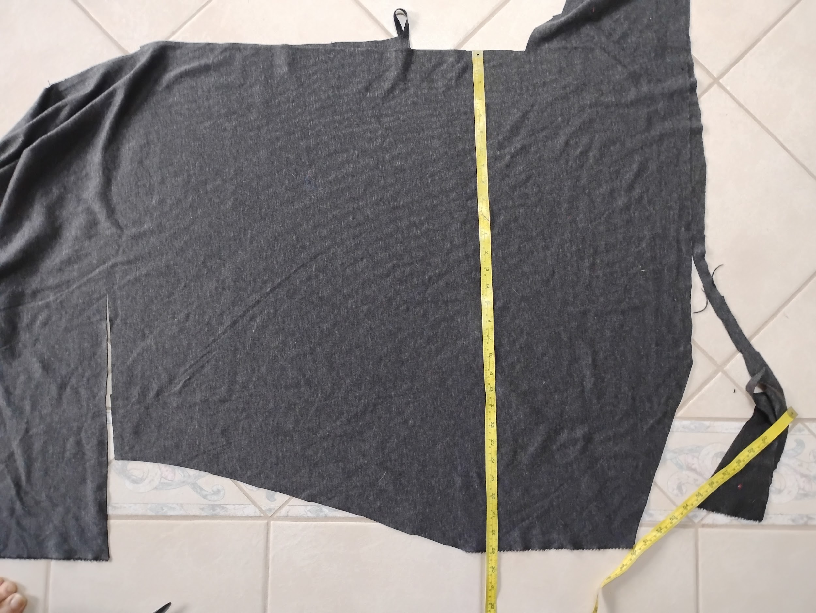

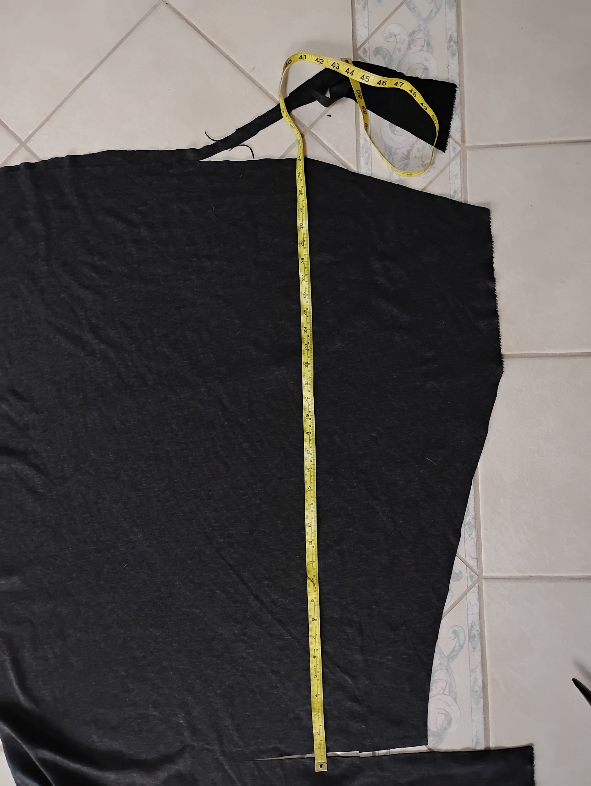
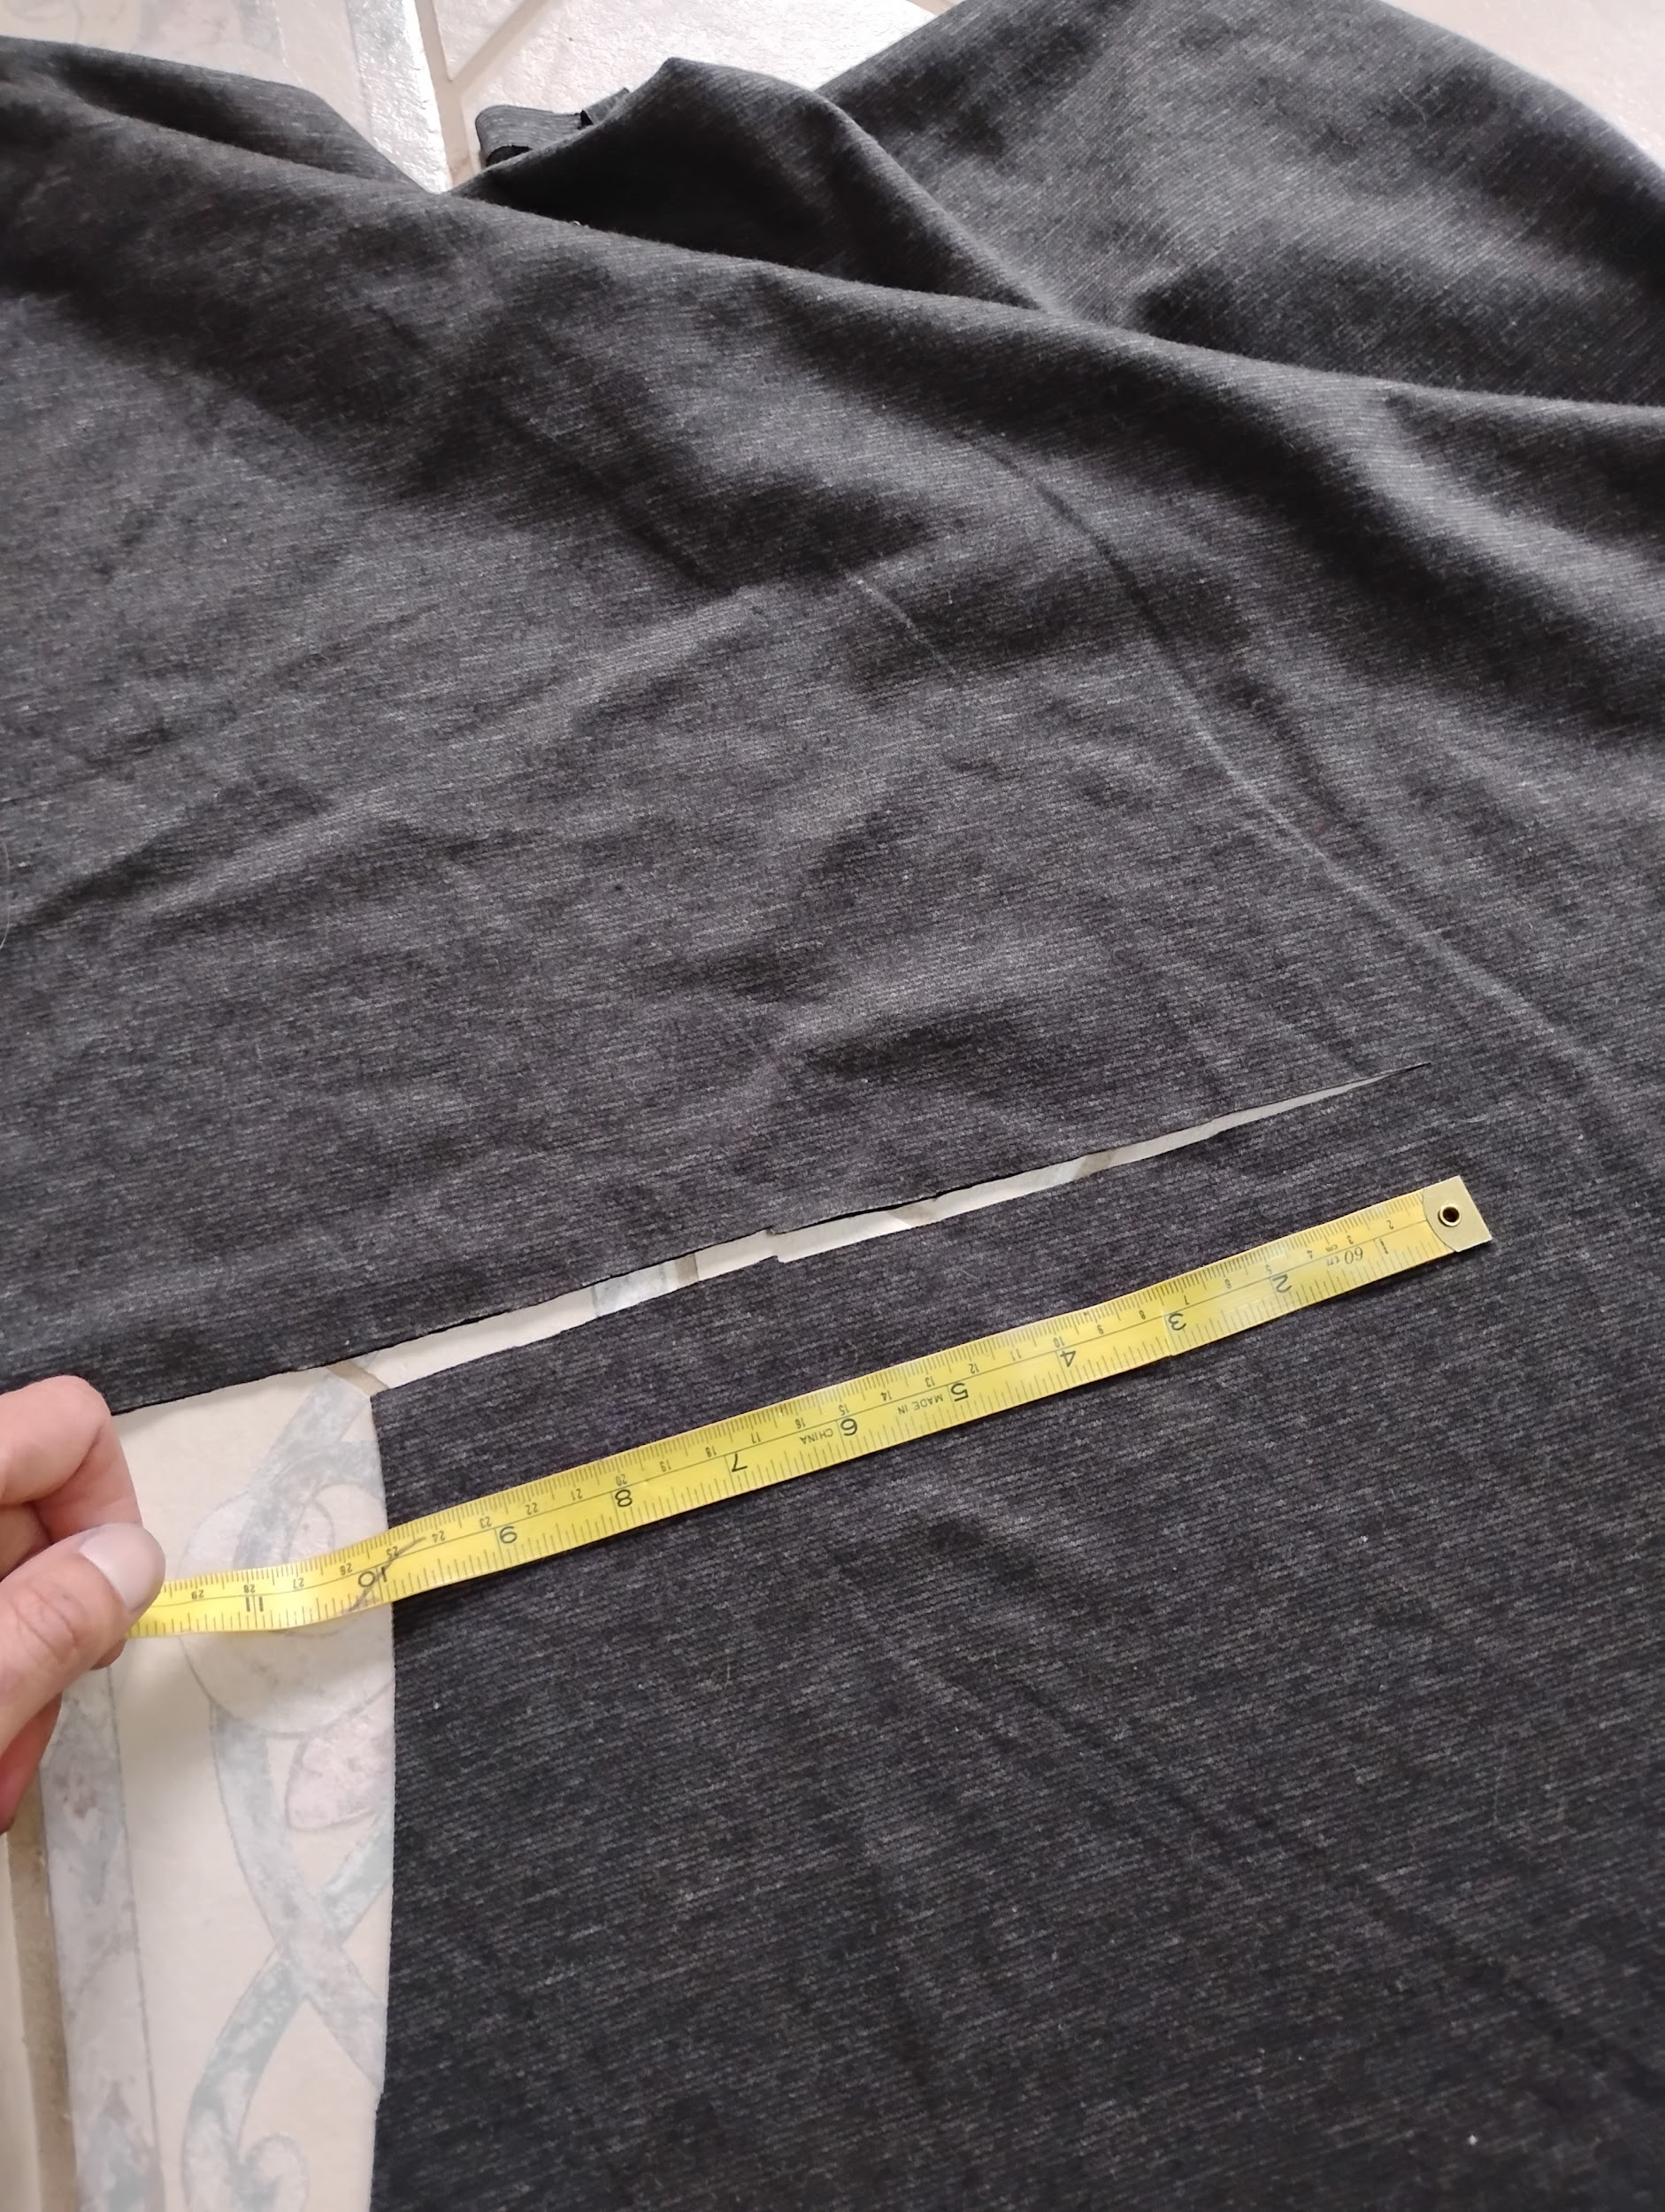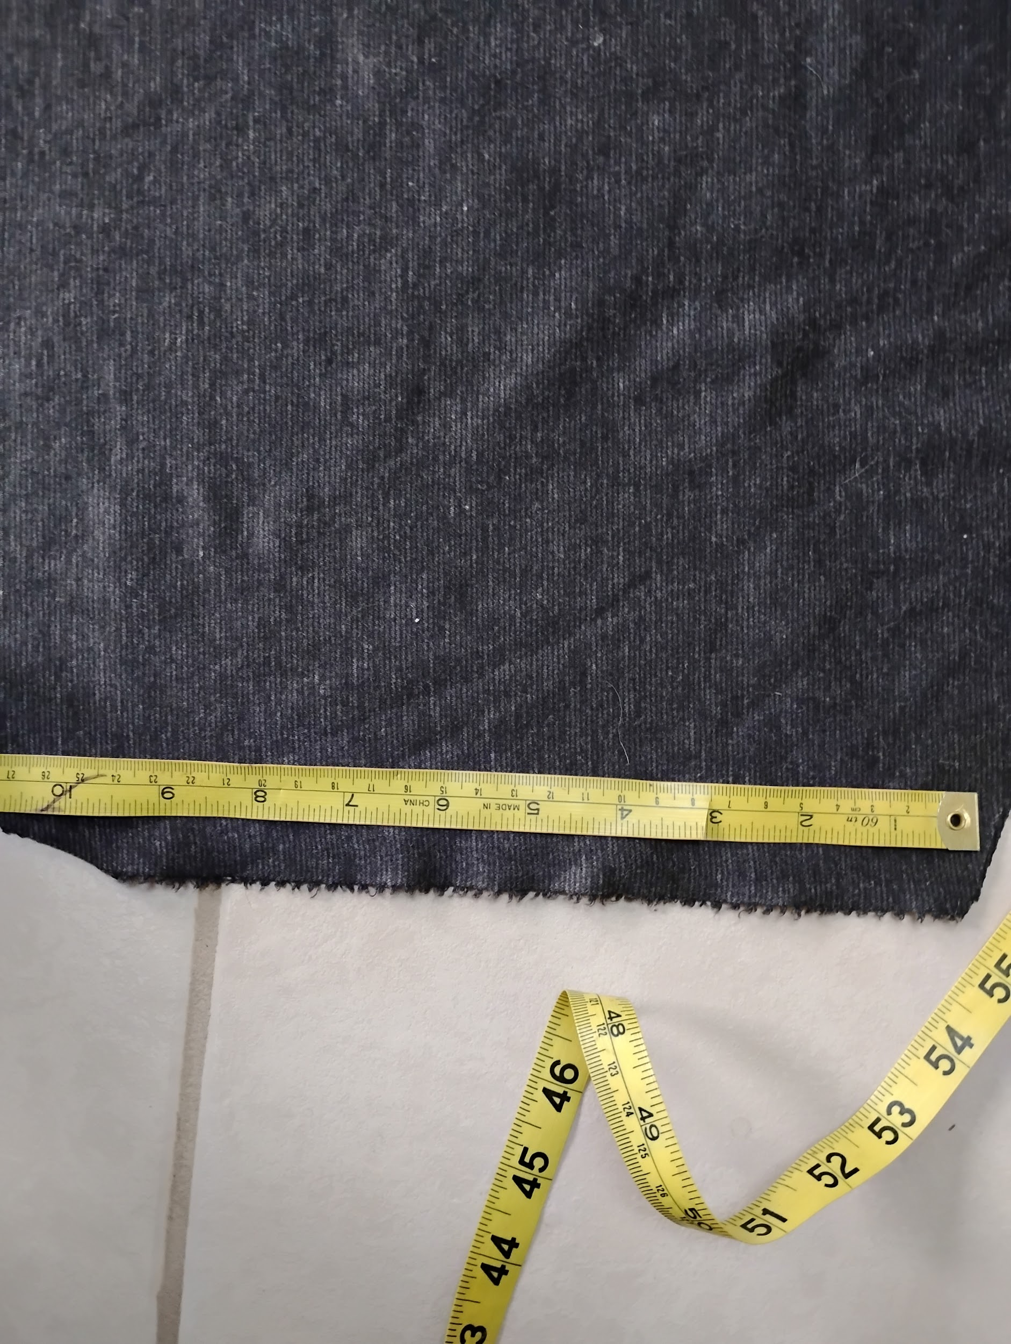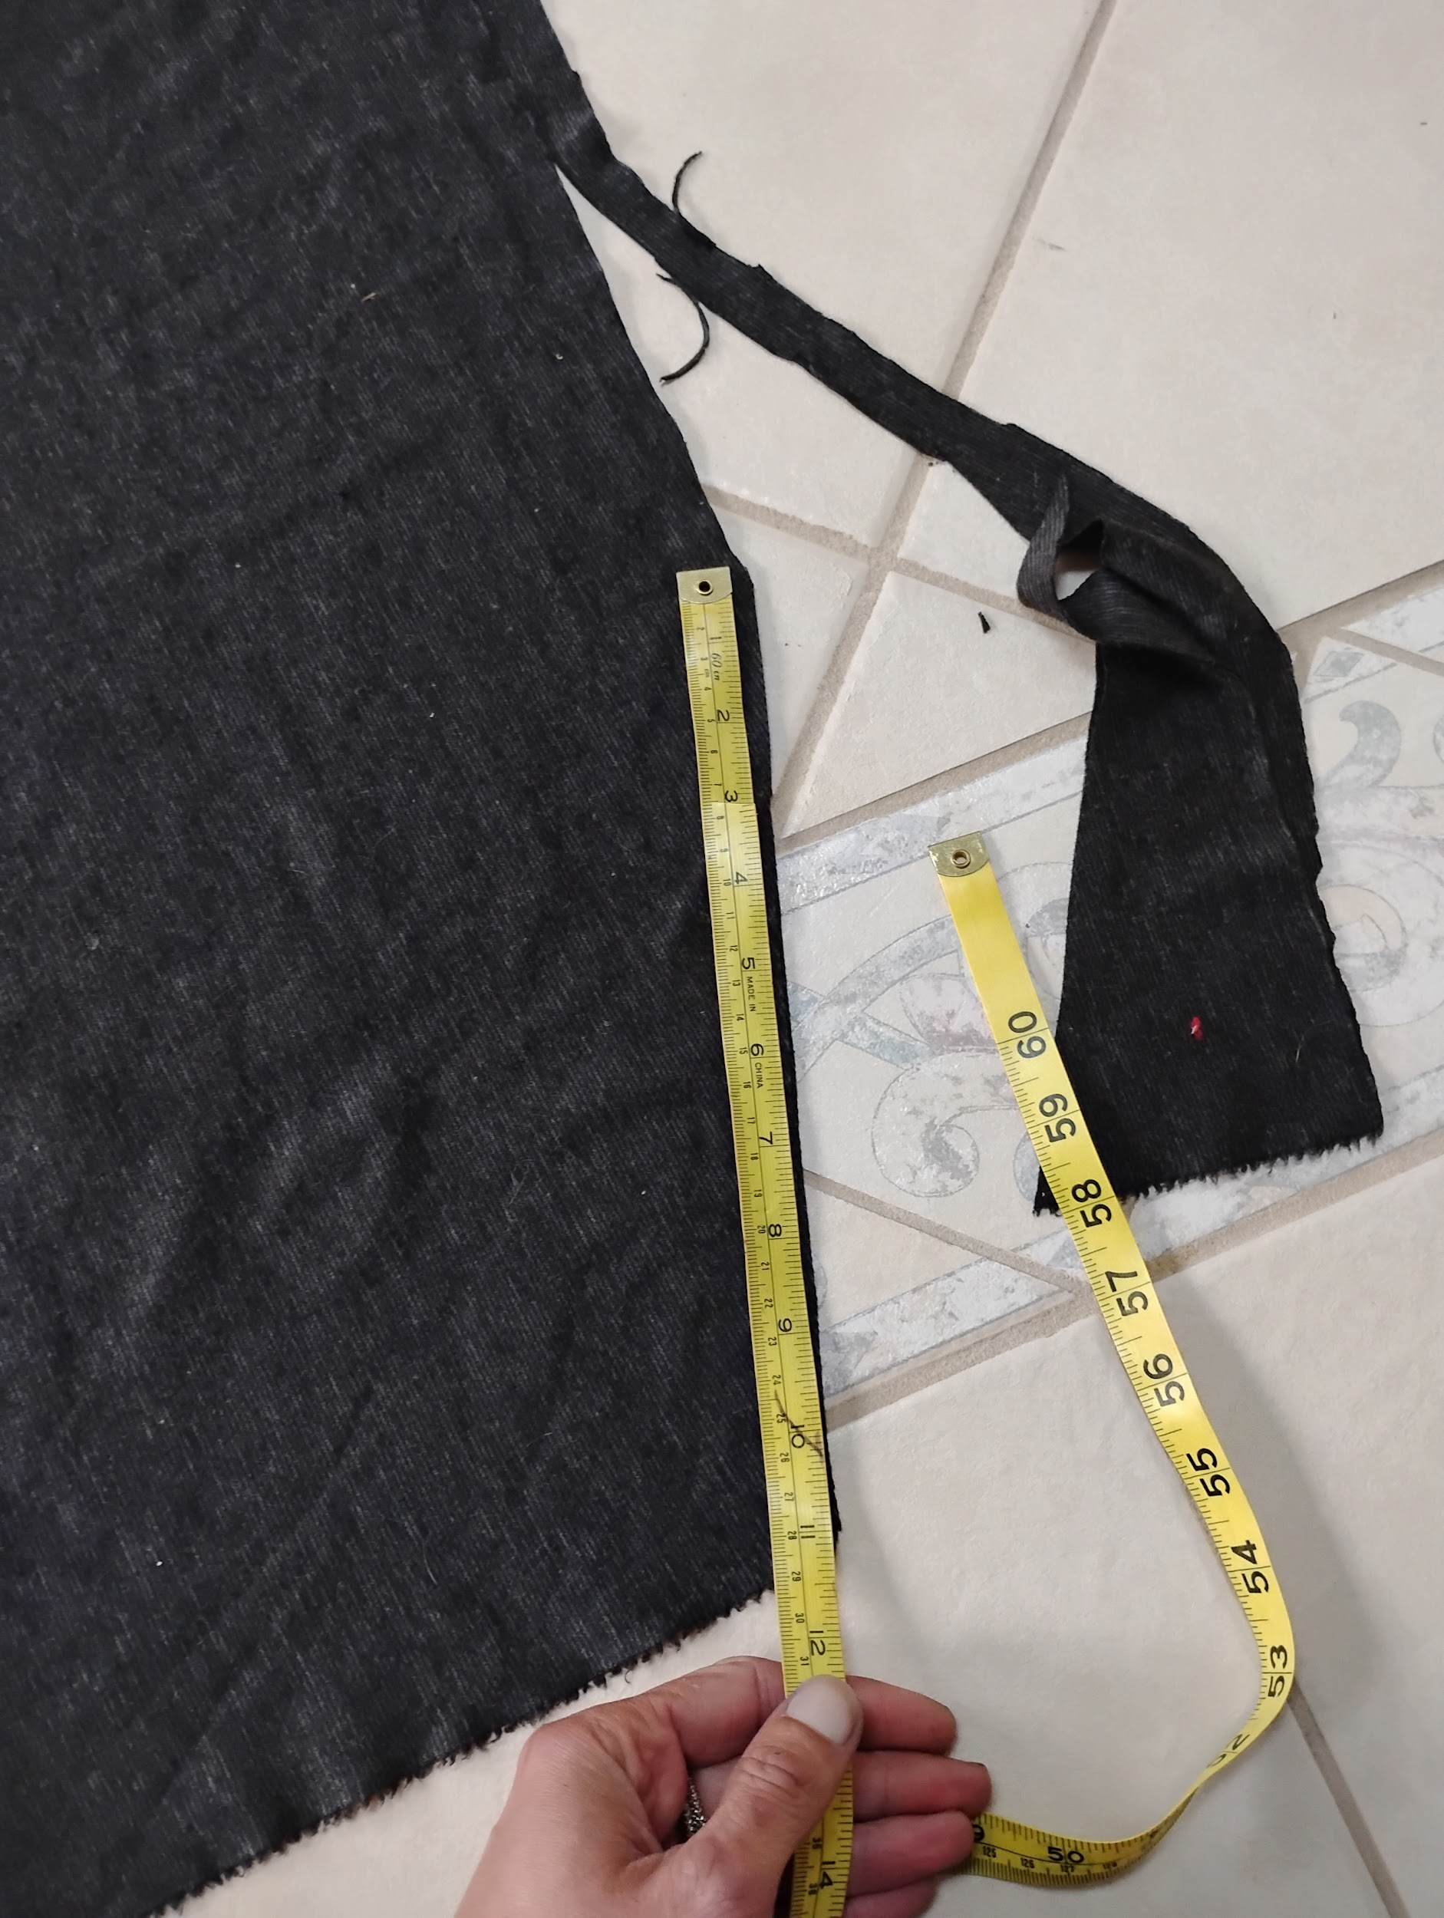

Step 2:

Fold it at the center and cut the other side out. Keep in mind that my fabric was already layered so at this point I have a front and back that are layered, folded in half hotdog style down the front and back lines and laying like so.

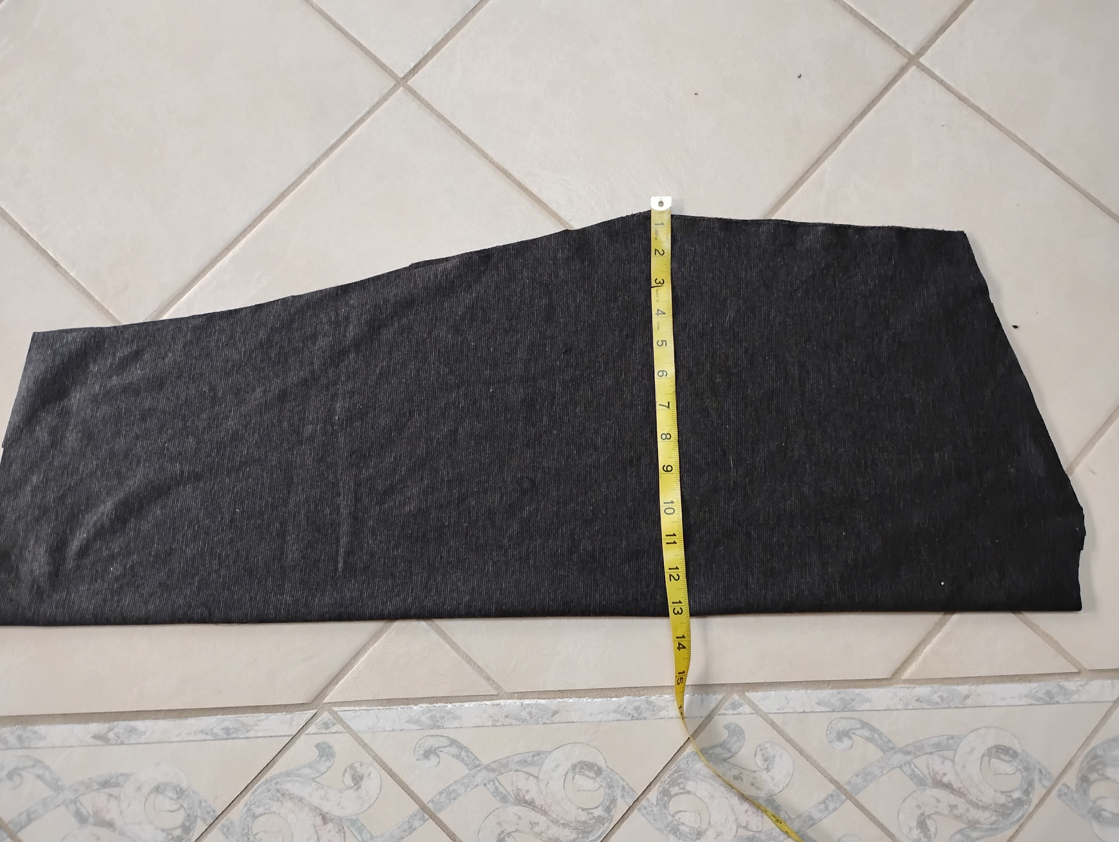

Step 3:

The armhole measurement from the bodice should match this mark on the sleeve. This is where they will connect. As for the width of the sleeve, you can measure around your arm if you want a tight fit but I just used as much of the fabric as I could. If you're using a knit, try not to cut your sleeve in the direction I did. It isn't tragic but you'll appreciate not having a super one way stretchy sleeve. Try to make the stretch go around the arm, not up and down the arm.

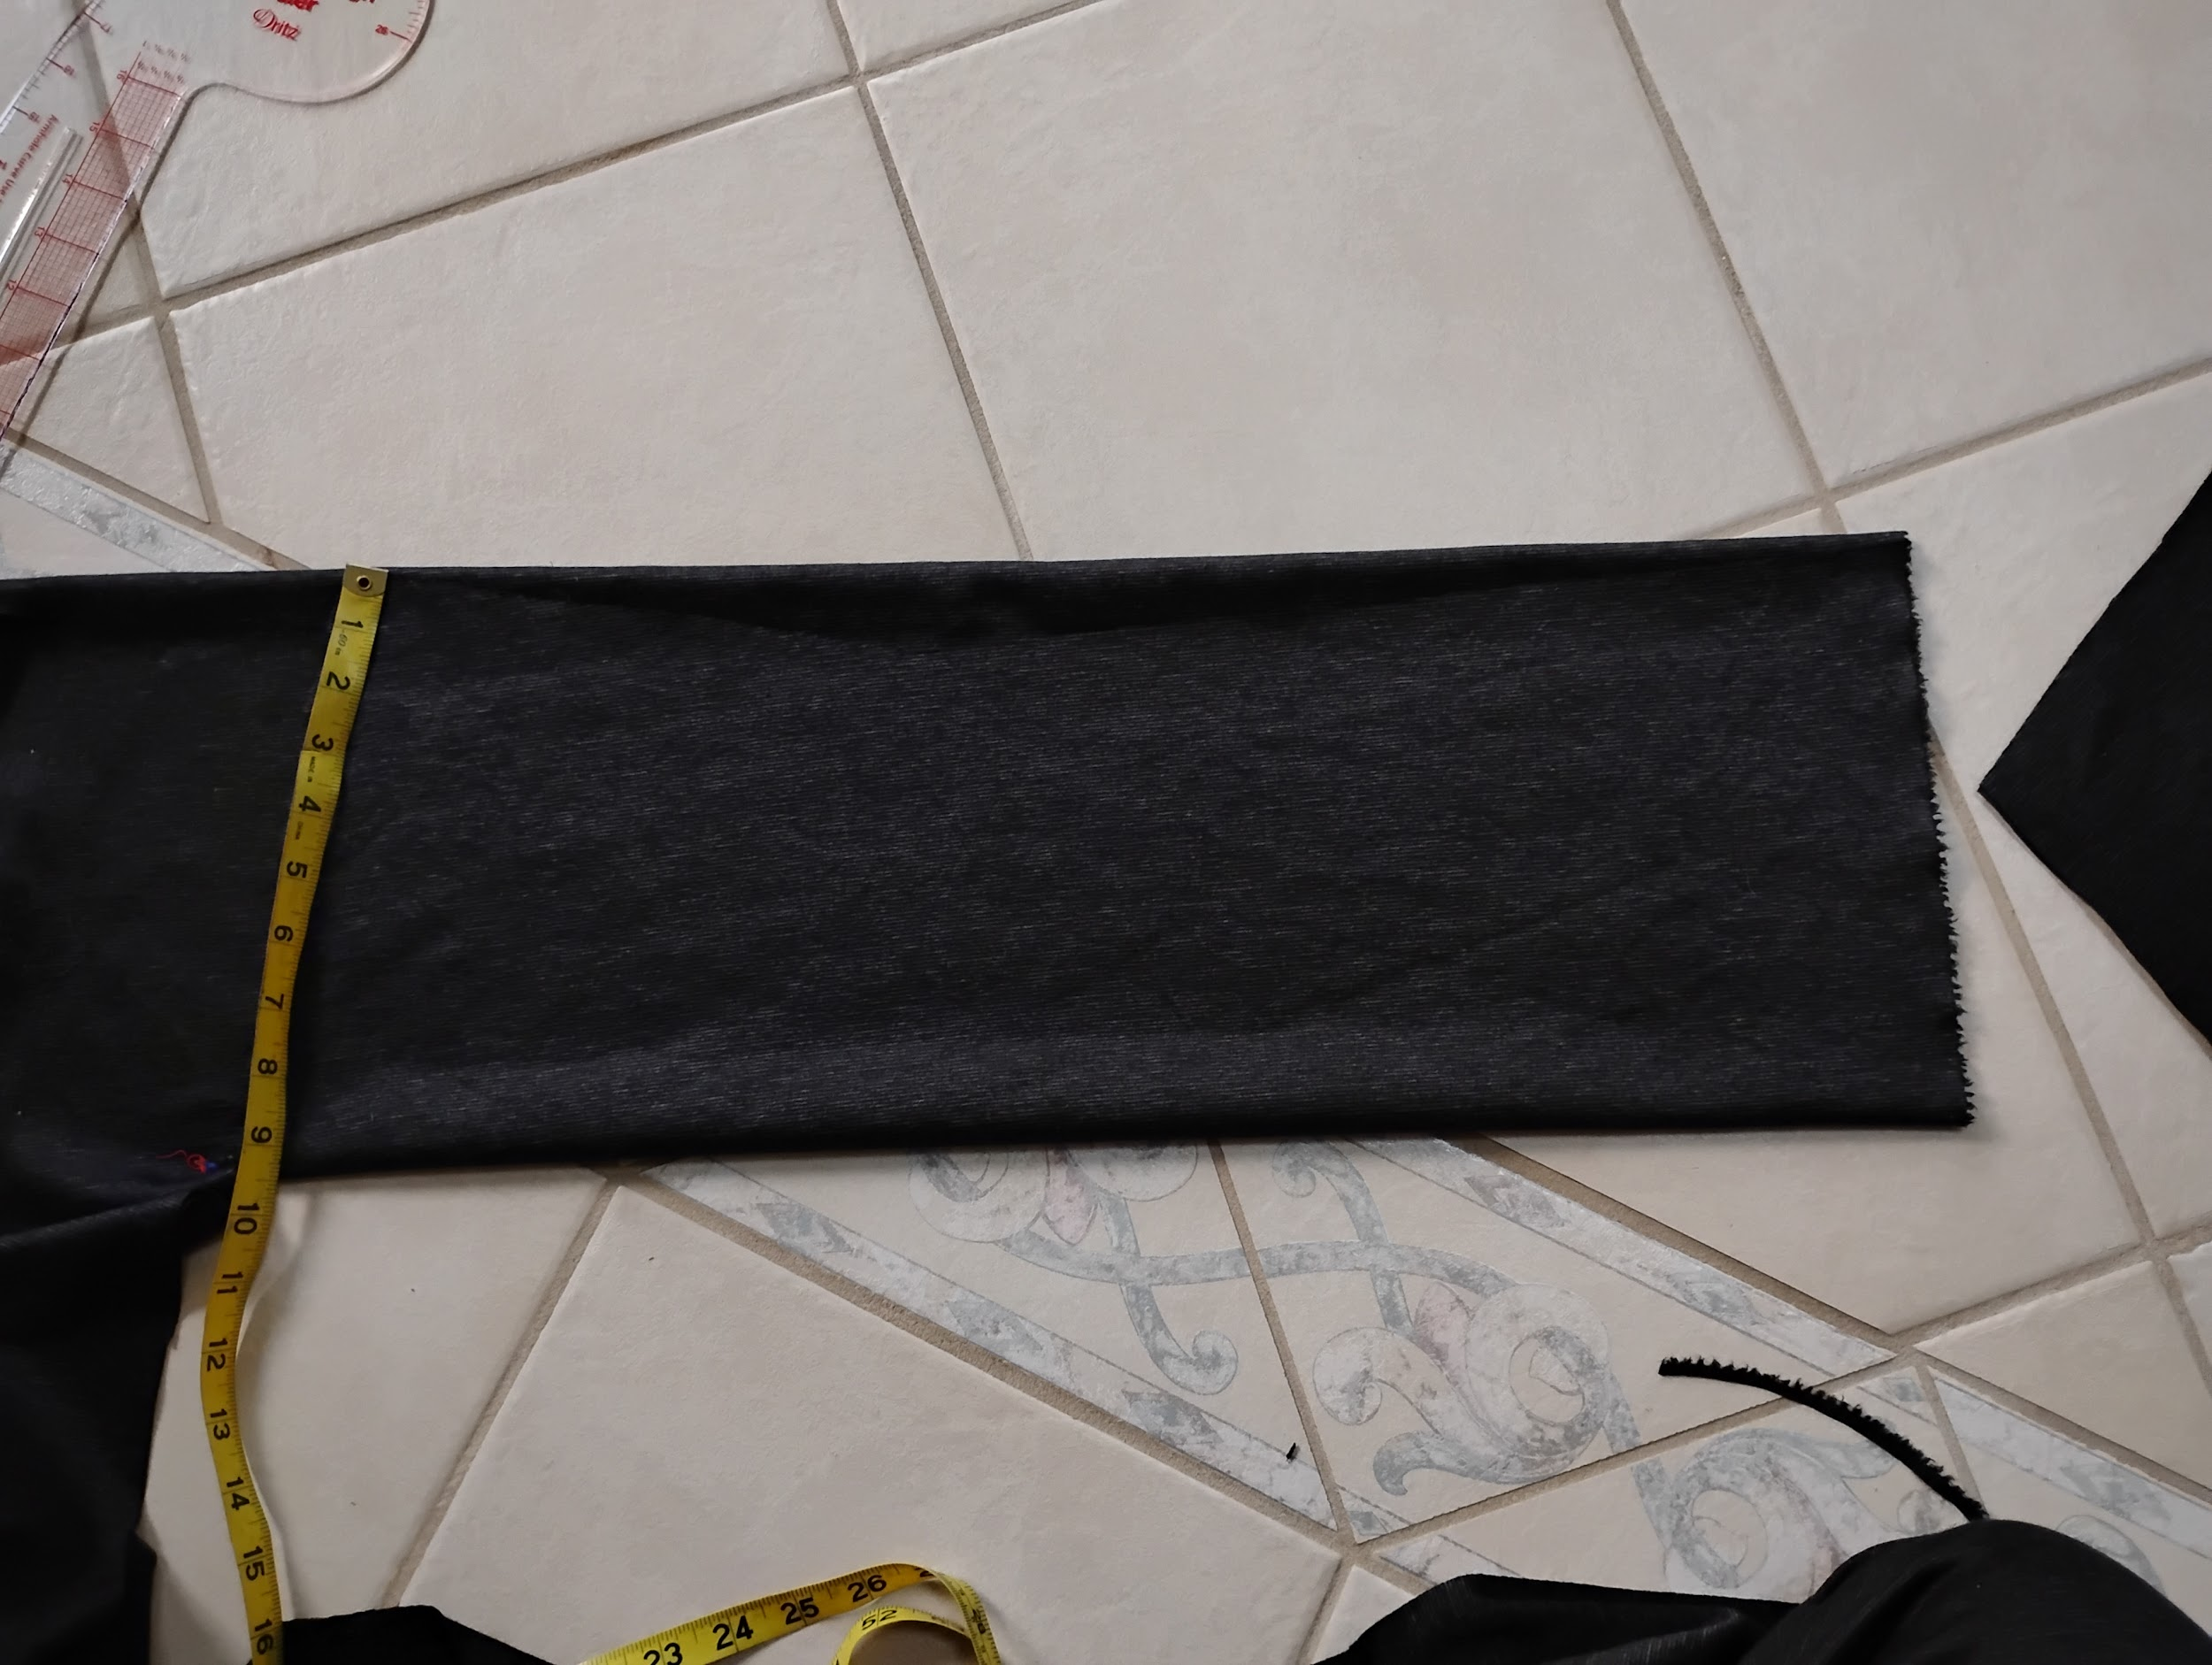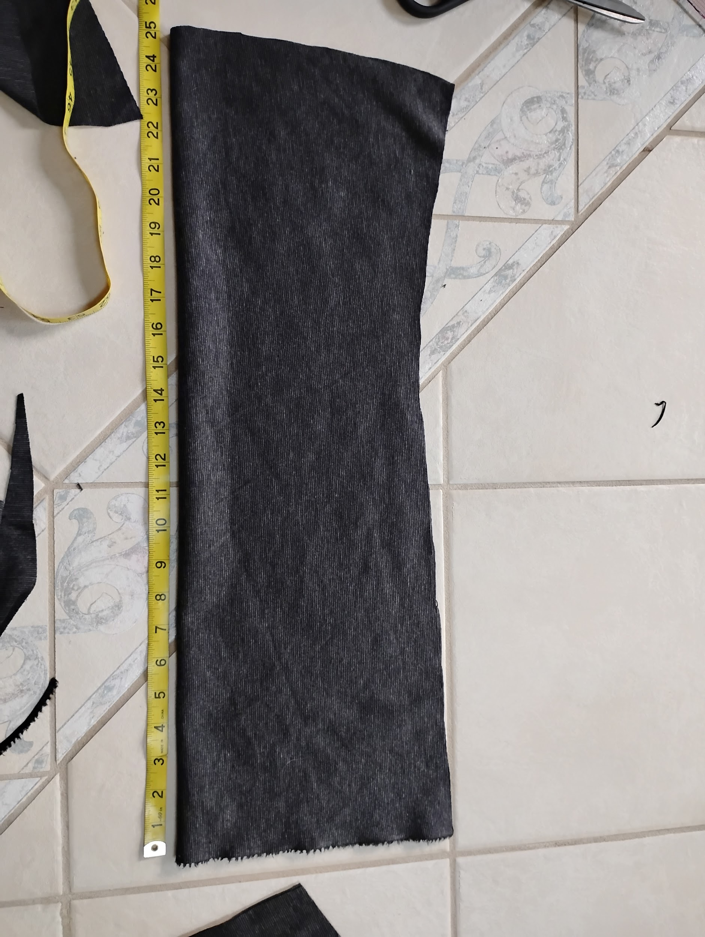

Step 4:

Cut out the neckline by determining how wide your neck is by measuring across the back of your neck and figuring out the comfortable spot for your neckline. I went with my back neck being 6”. In the front I'll cut down and make a slight scoop and repeat that on the other side. When it comes to doing the back neck i get highly distracted by Willy, a house cat. He loves being involved.

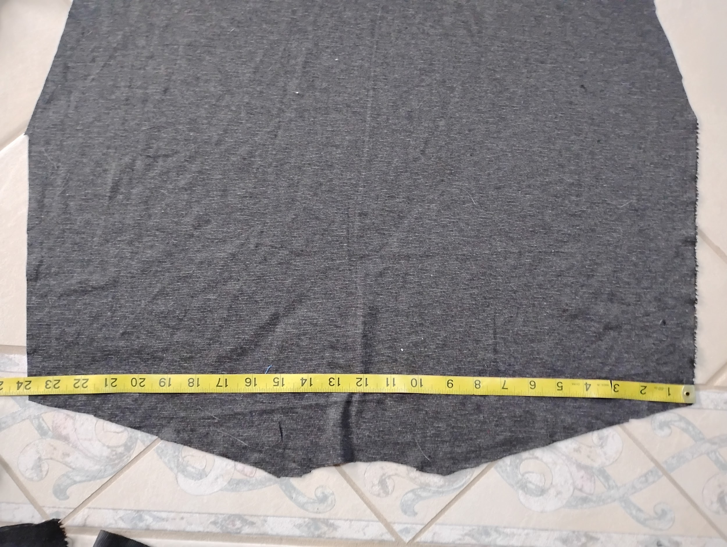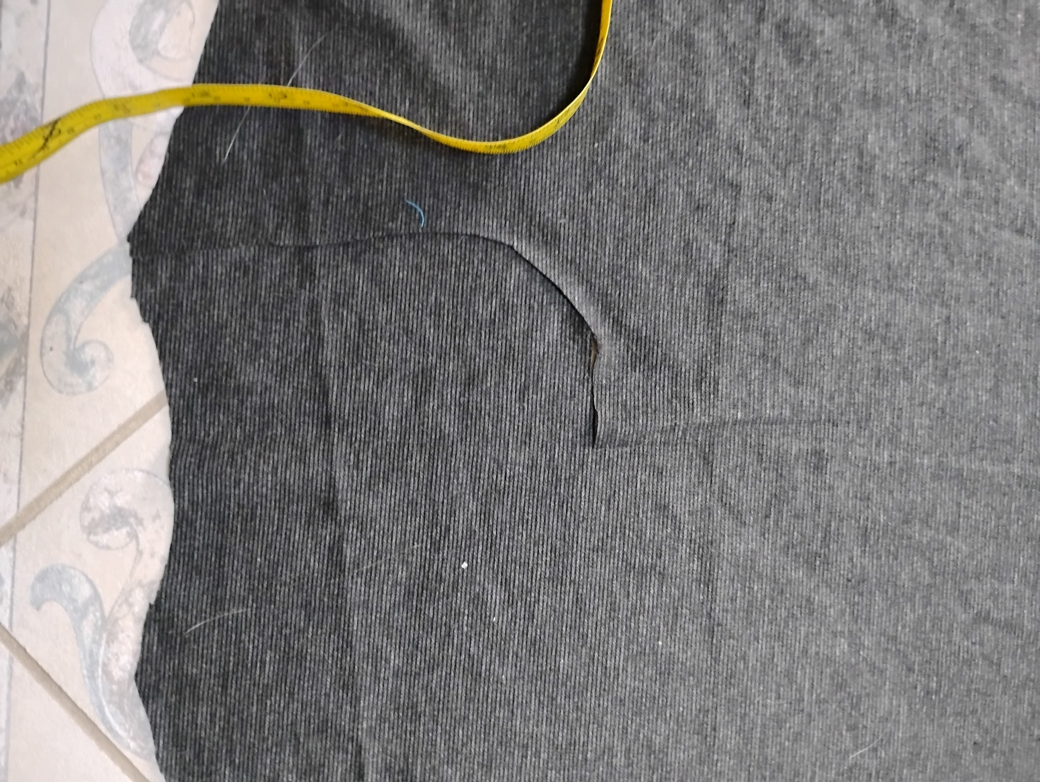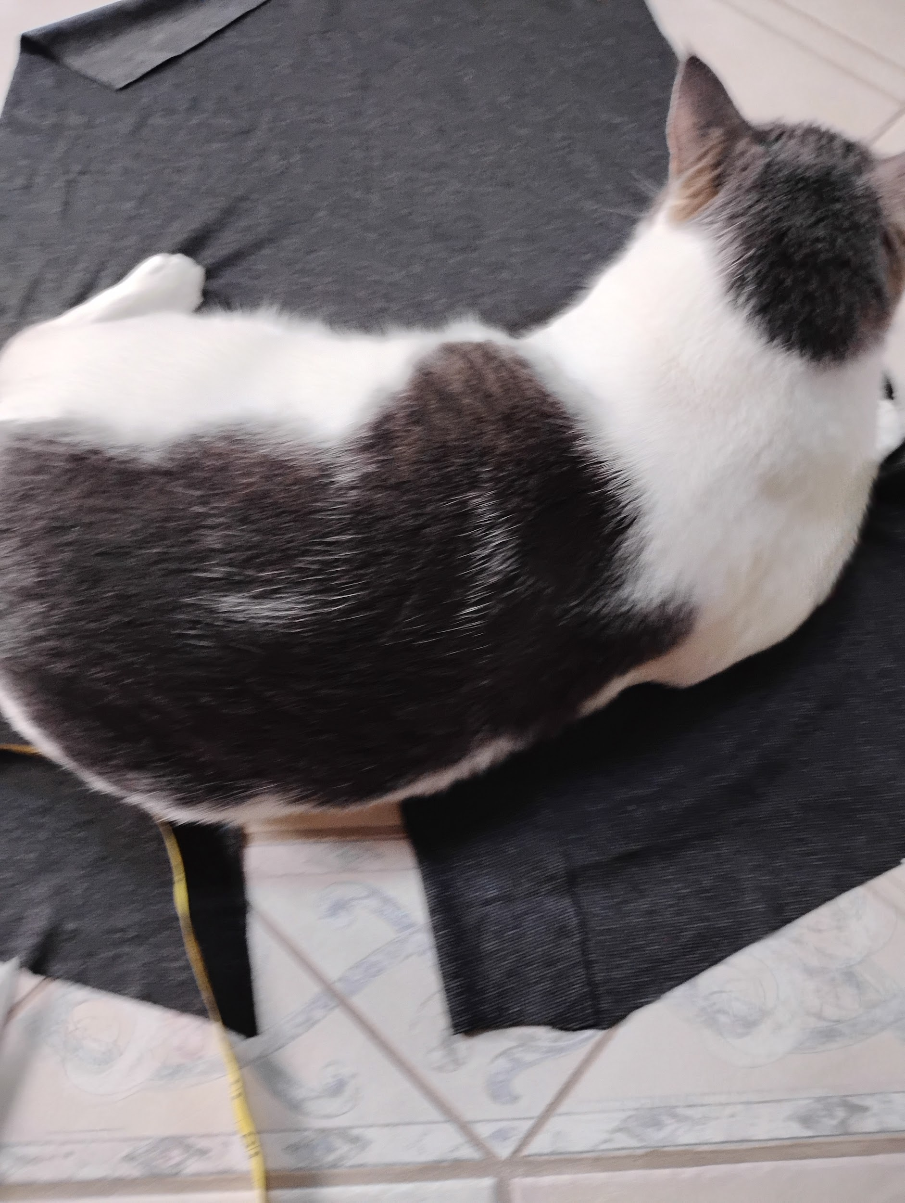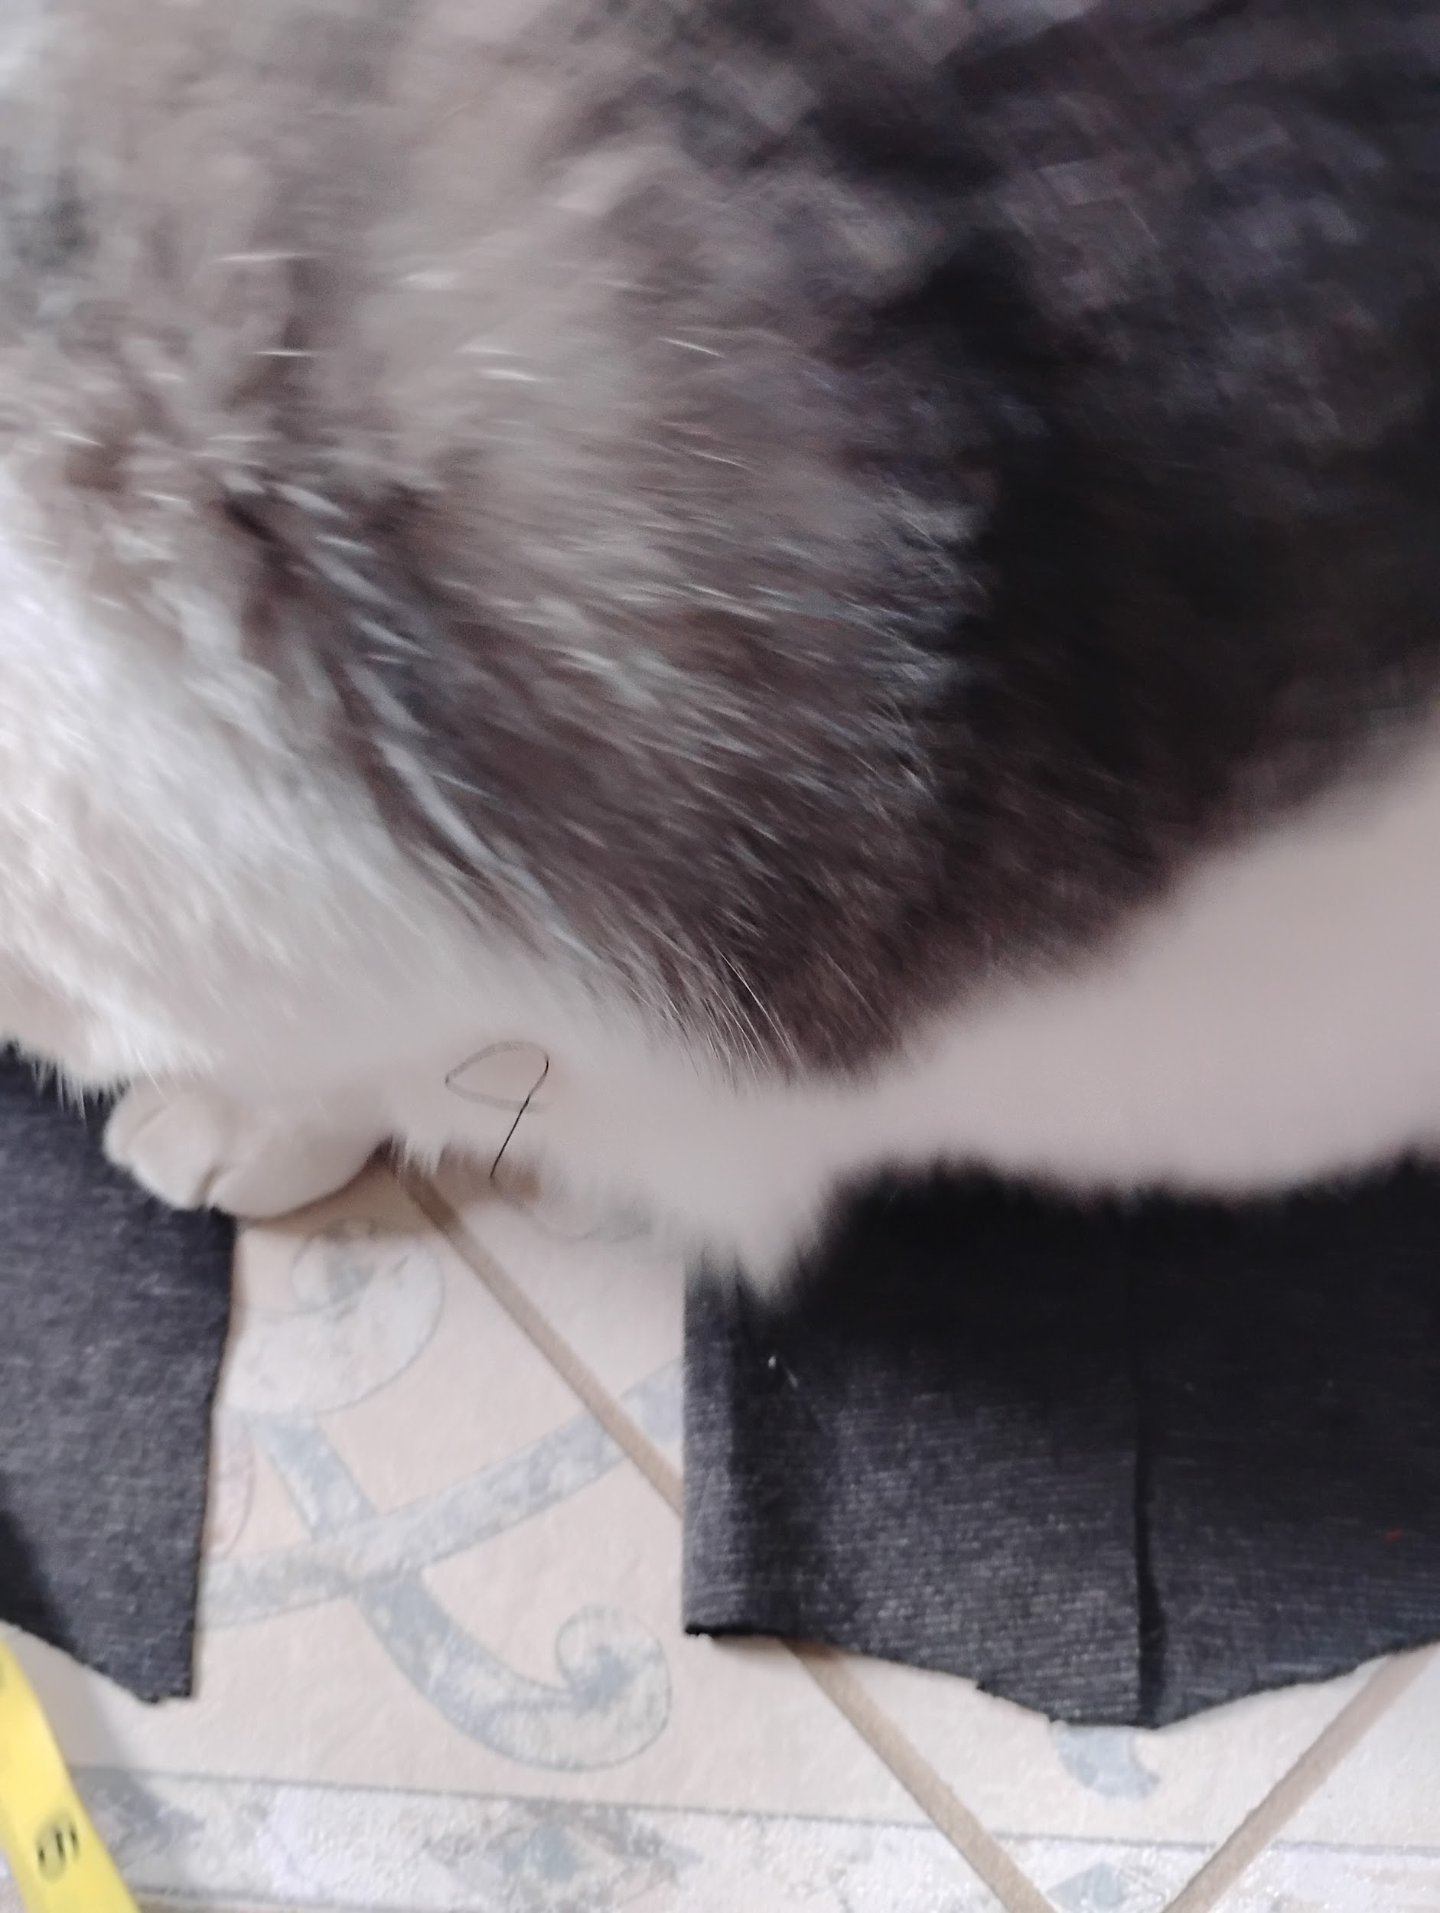
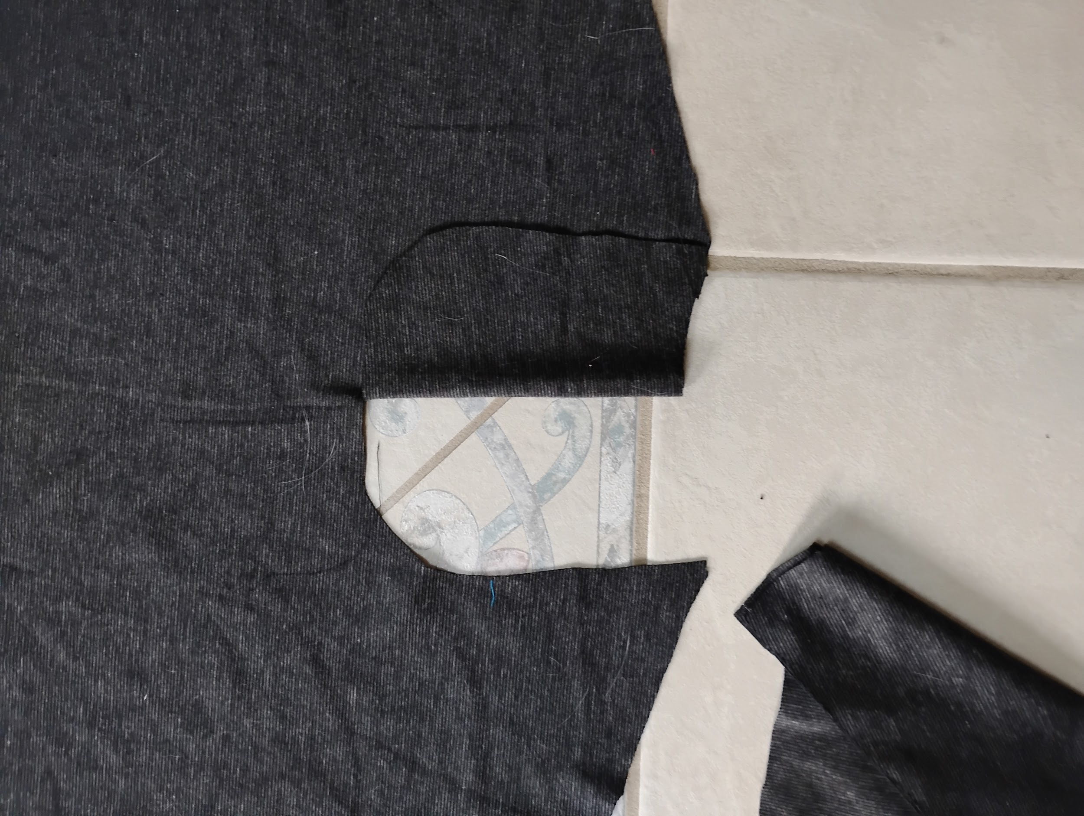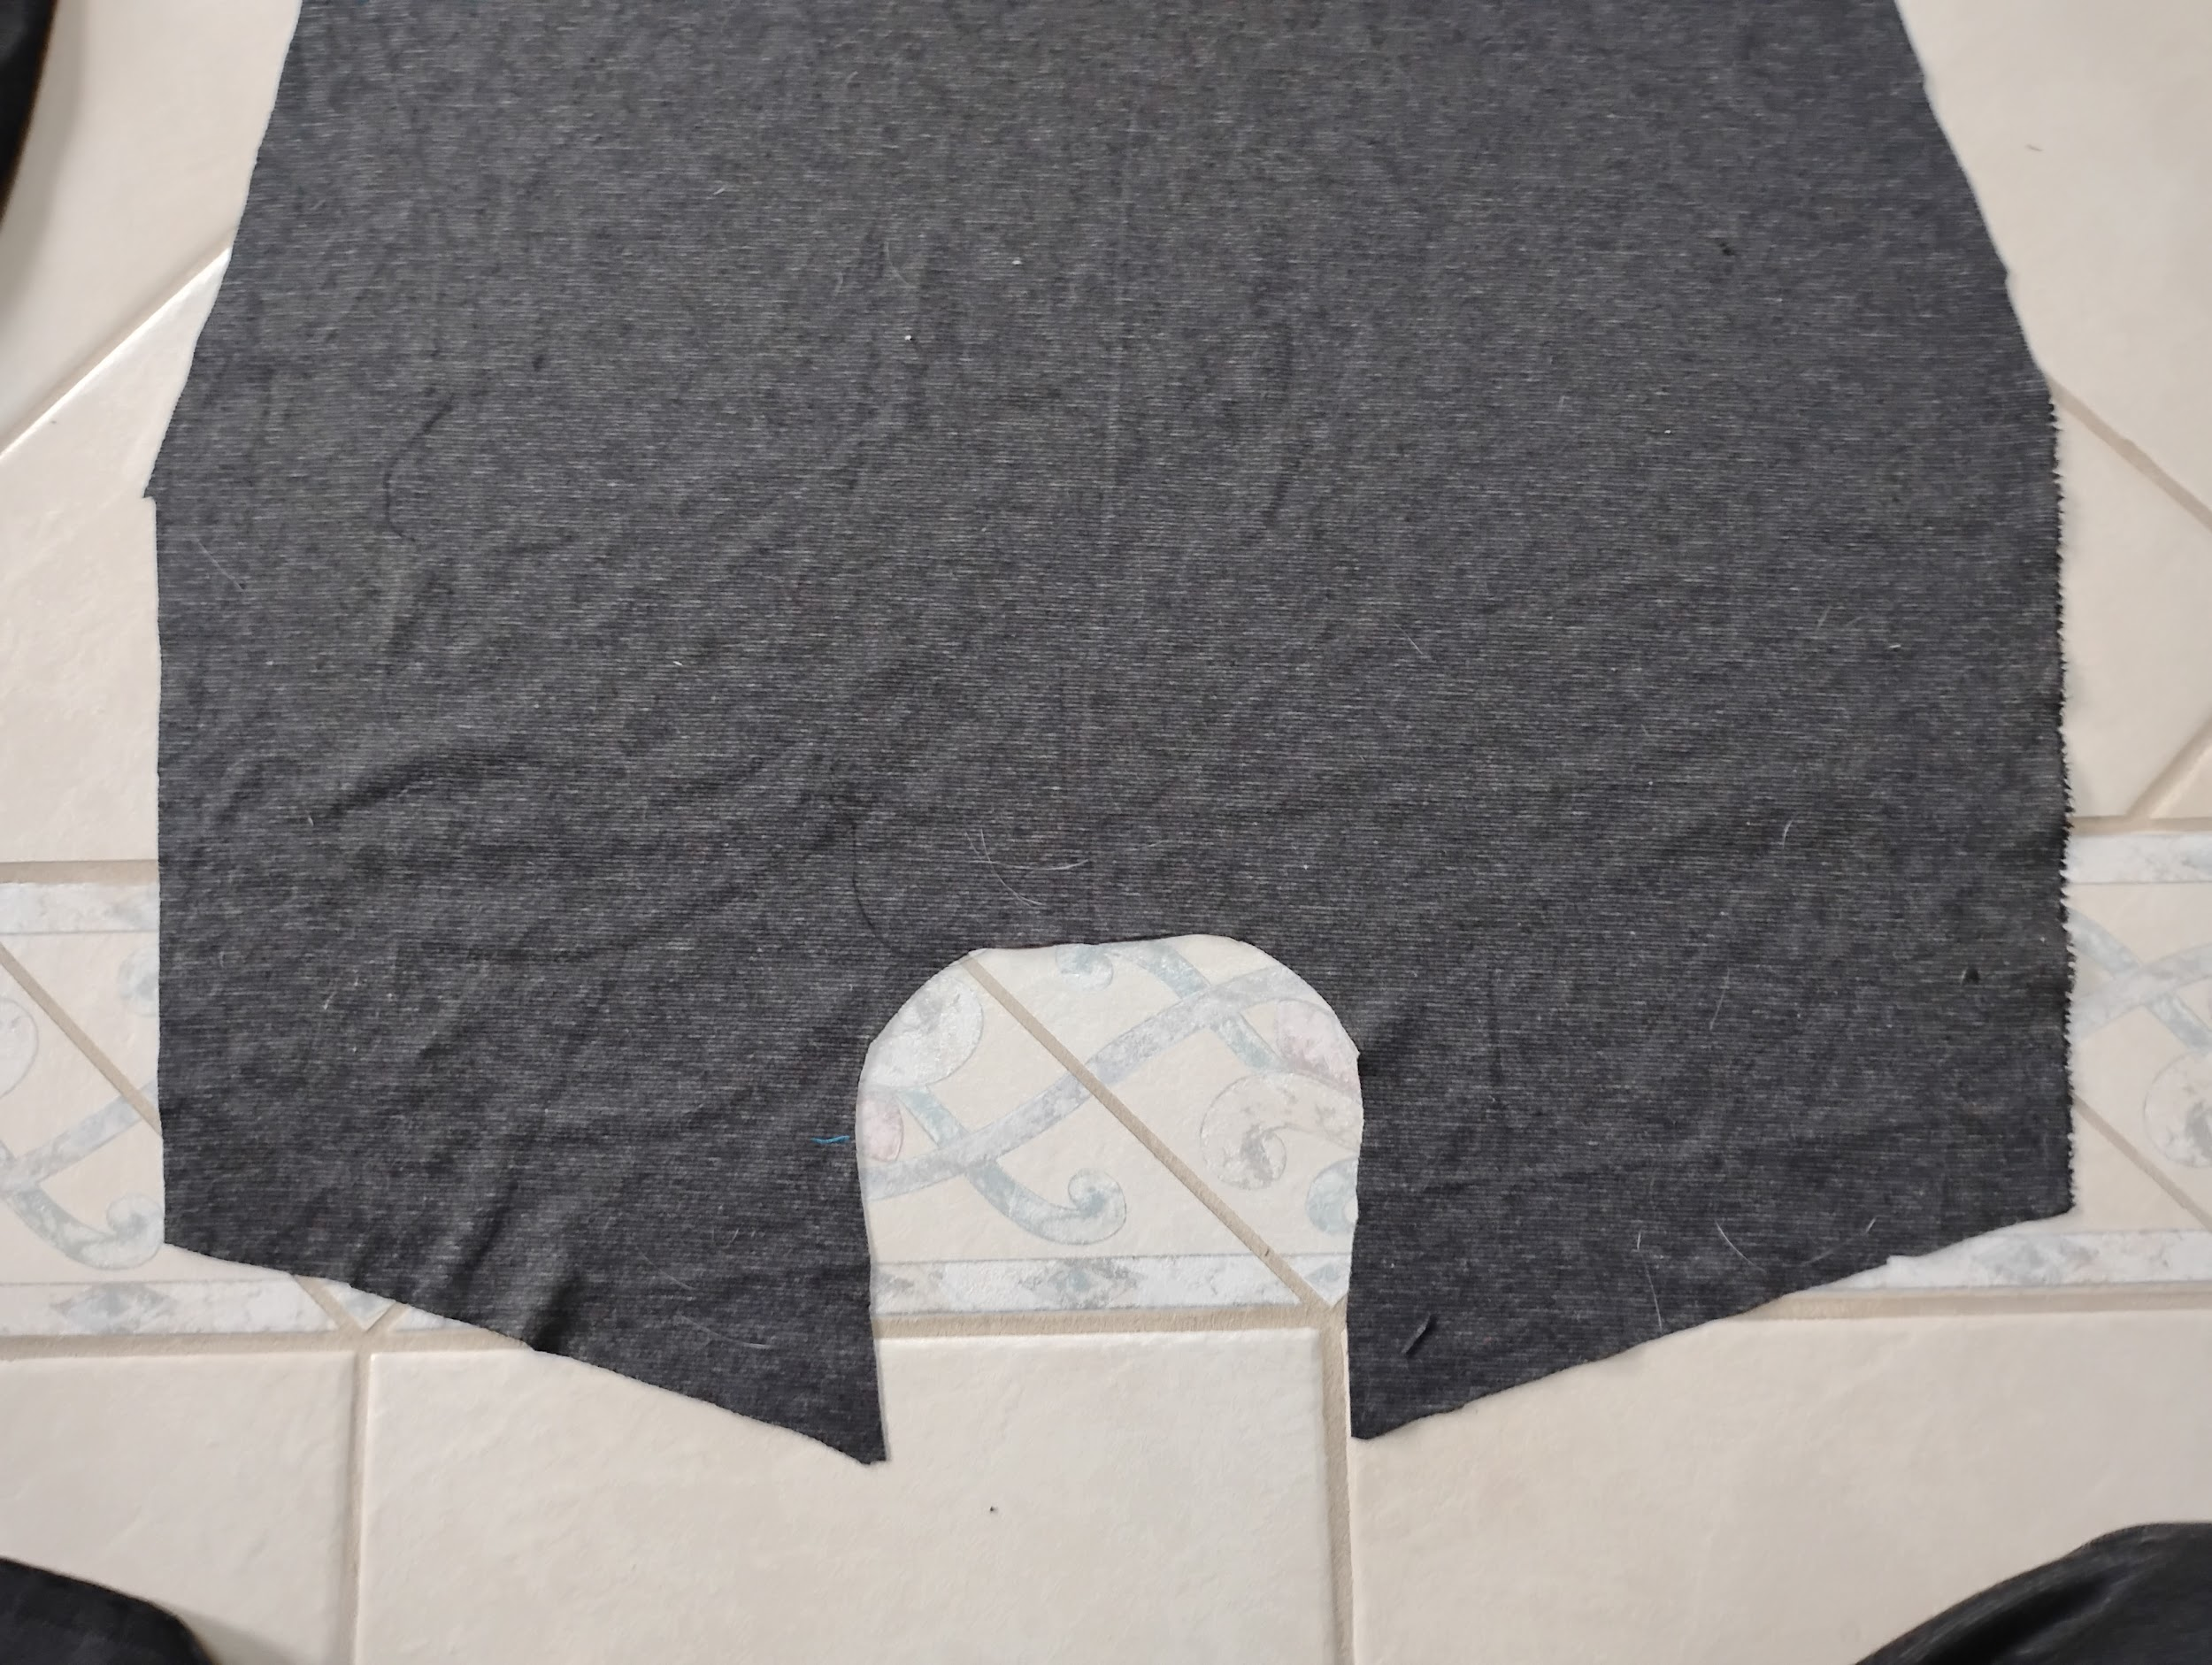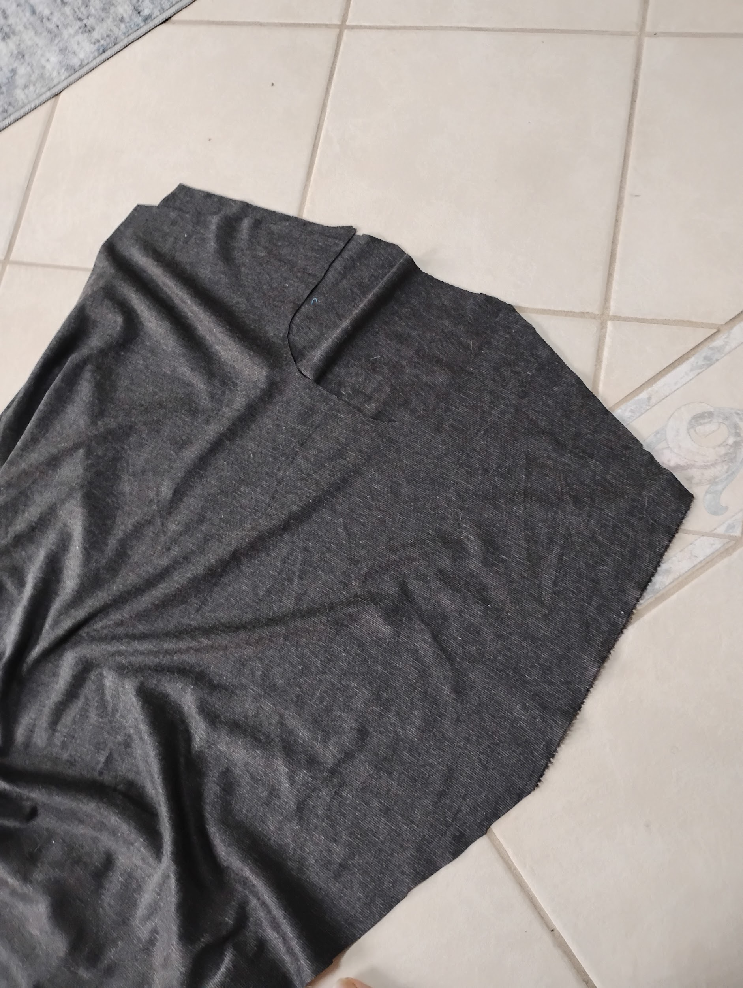

Step 5:

Sew the arms from the neck hole down to the shoulder.

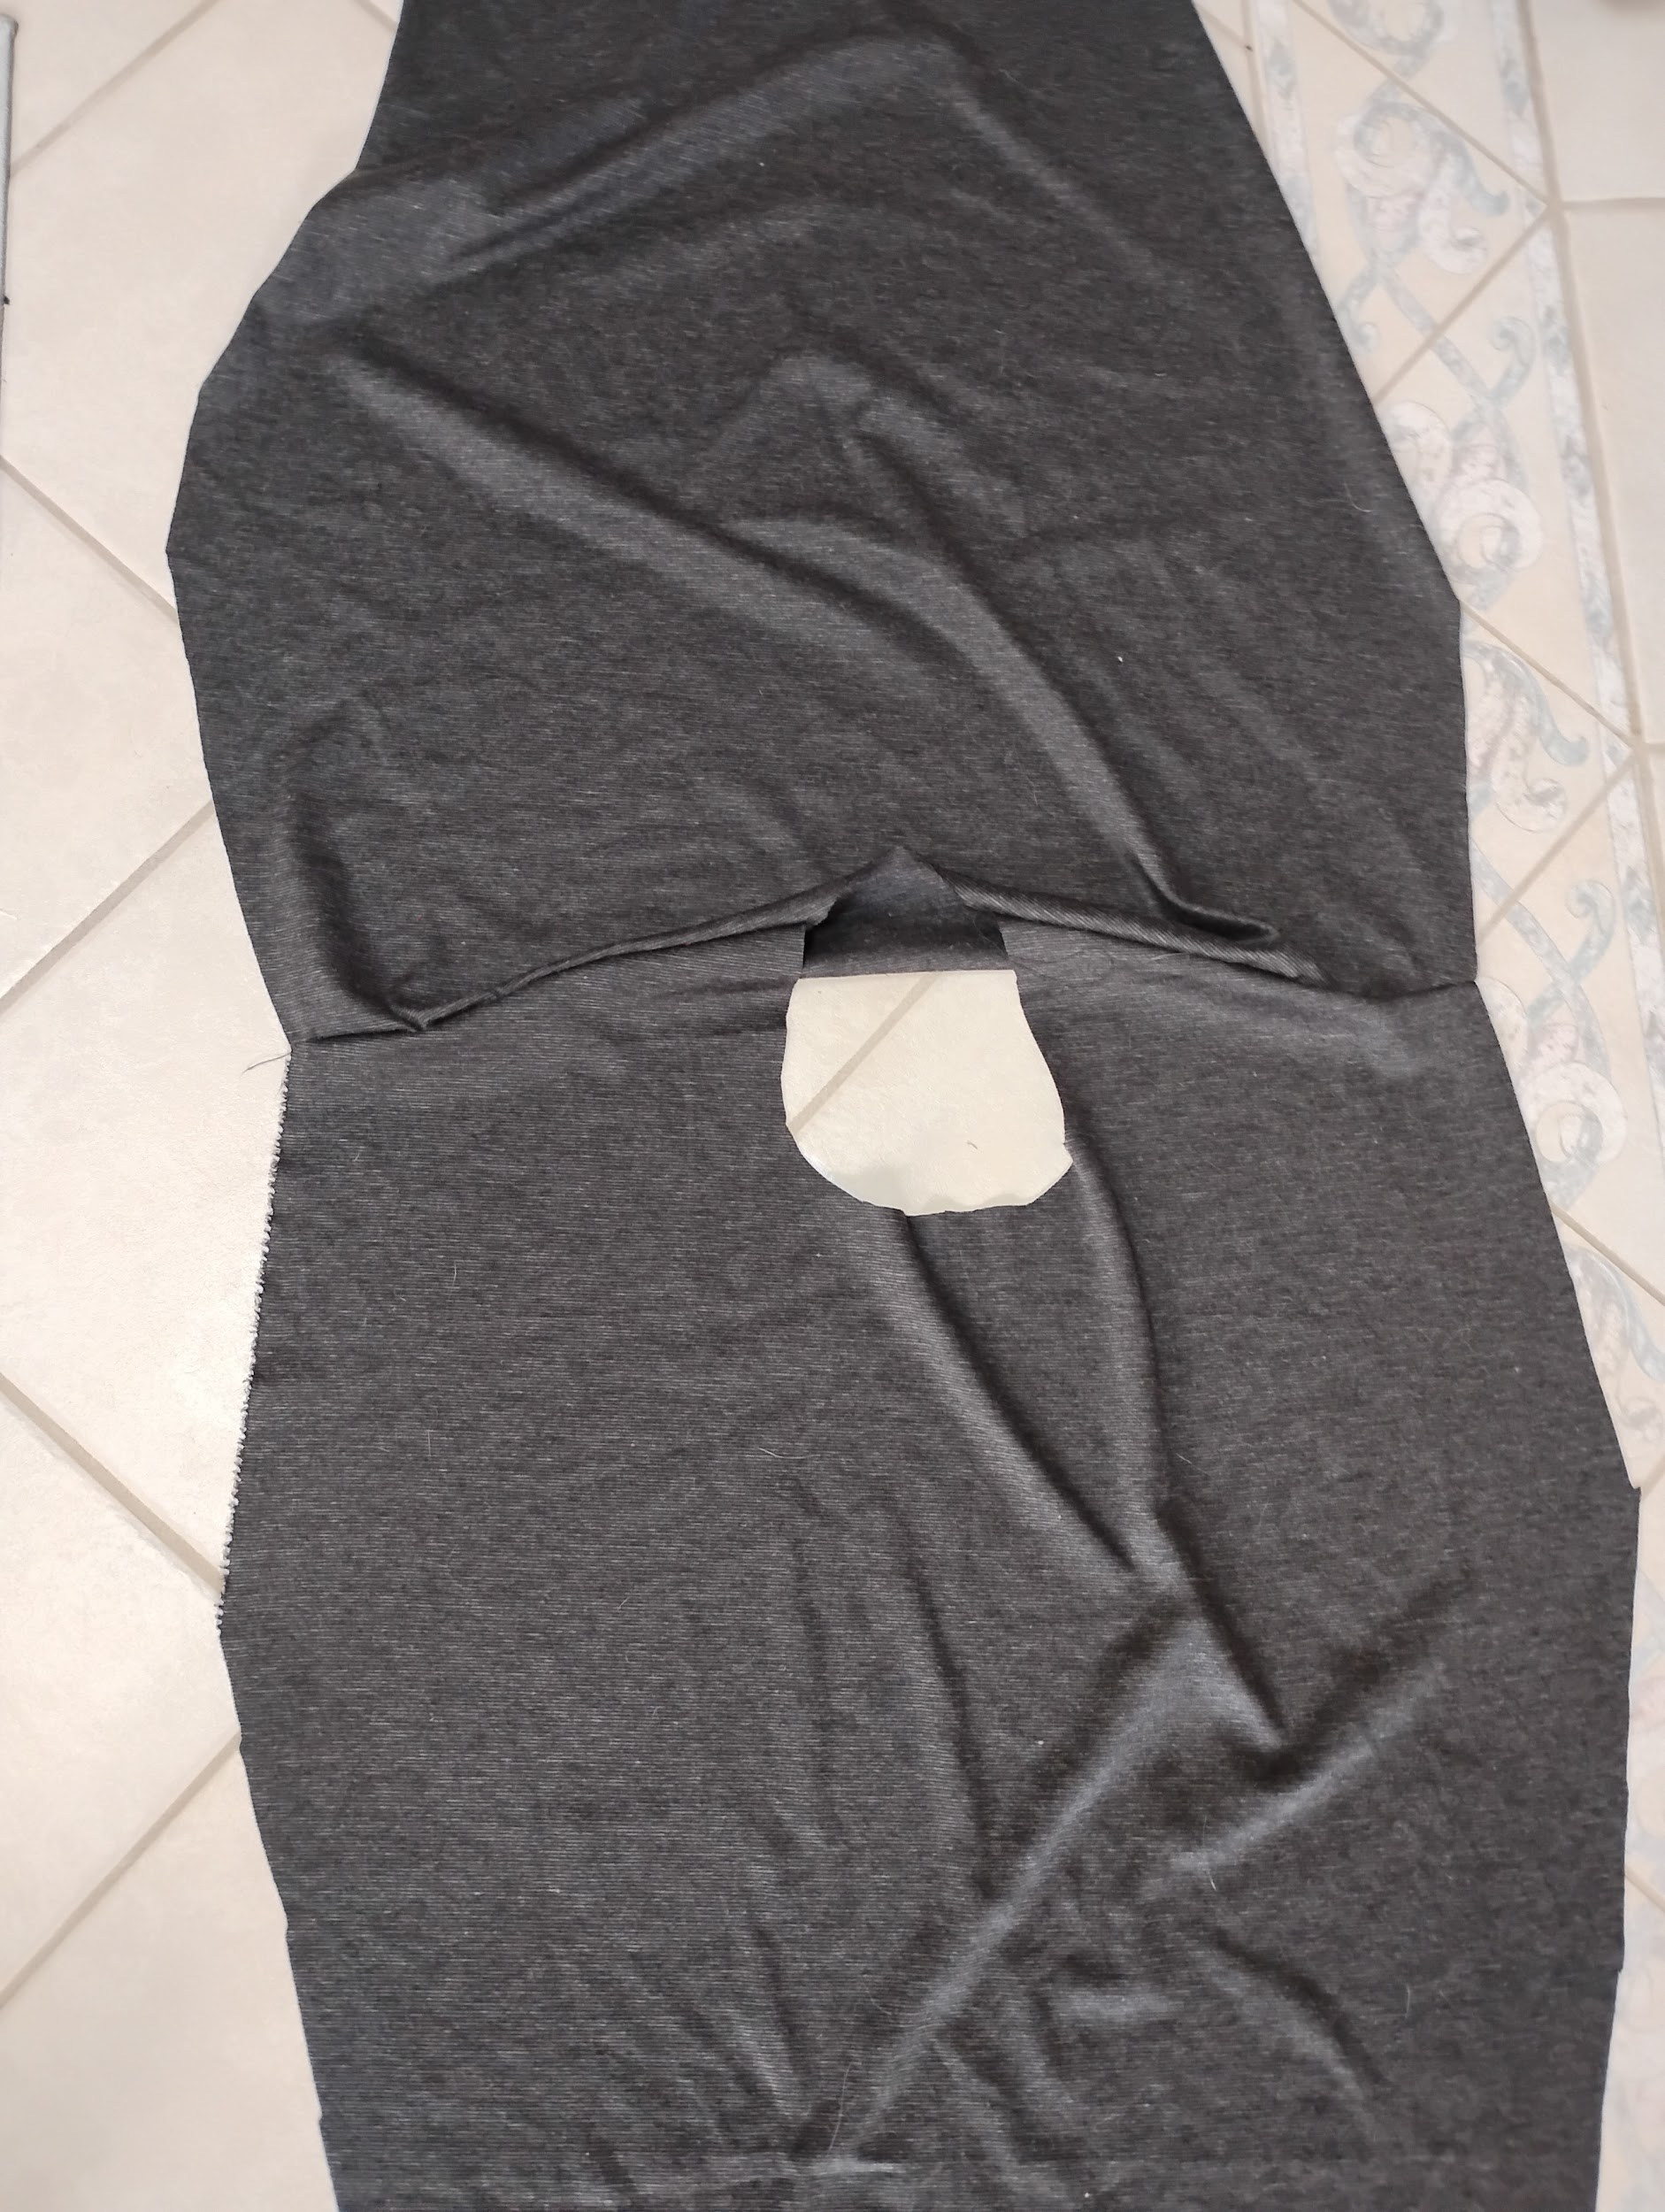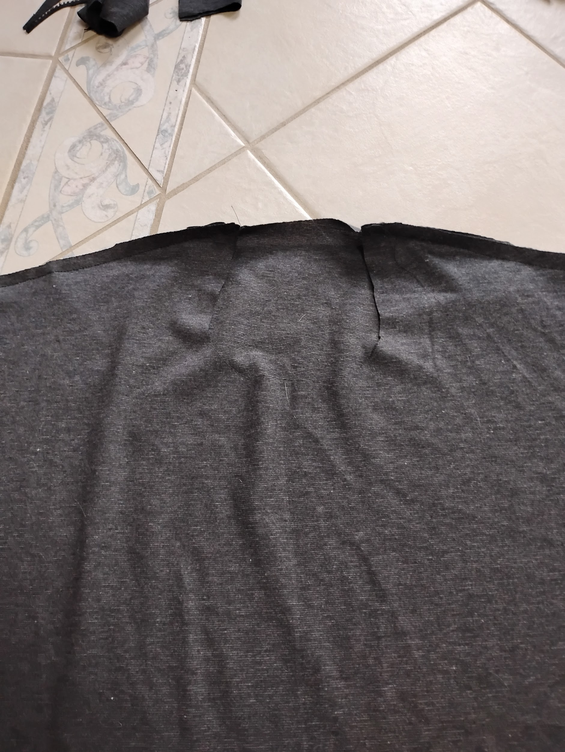

Step 6:

Sew the sleeves on by connecting the top of the sleeve halfway on the shoulder seams. Half of the sleeve goes on the front bodice and the other half on the back.

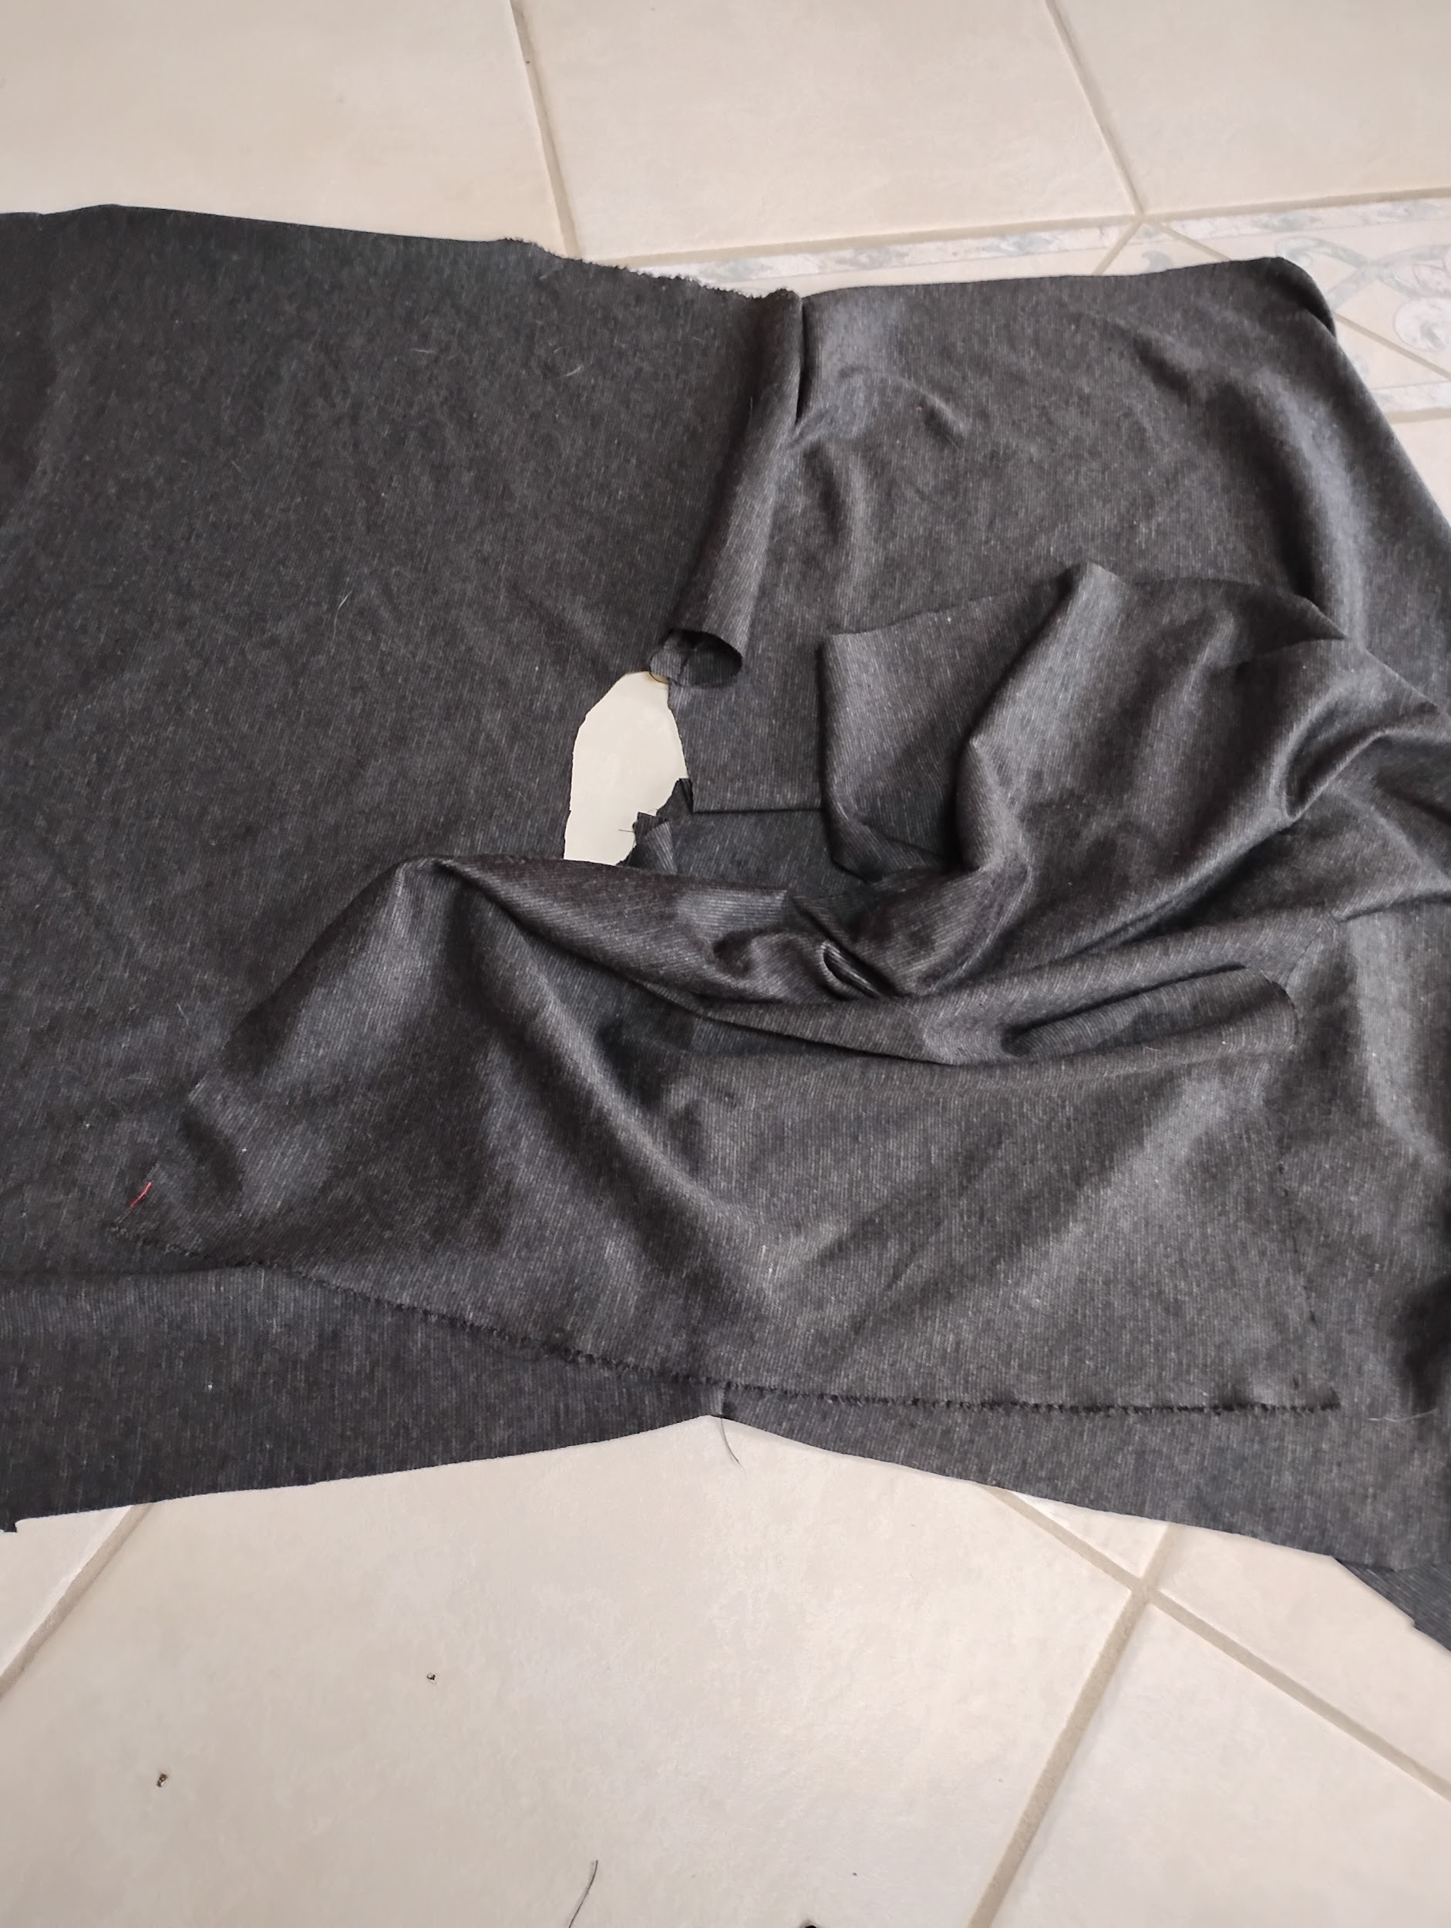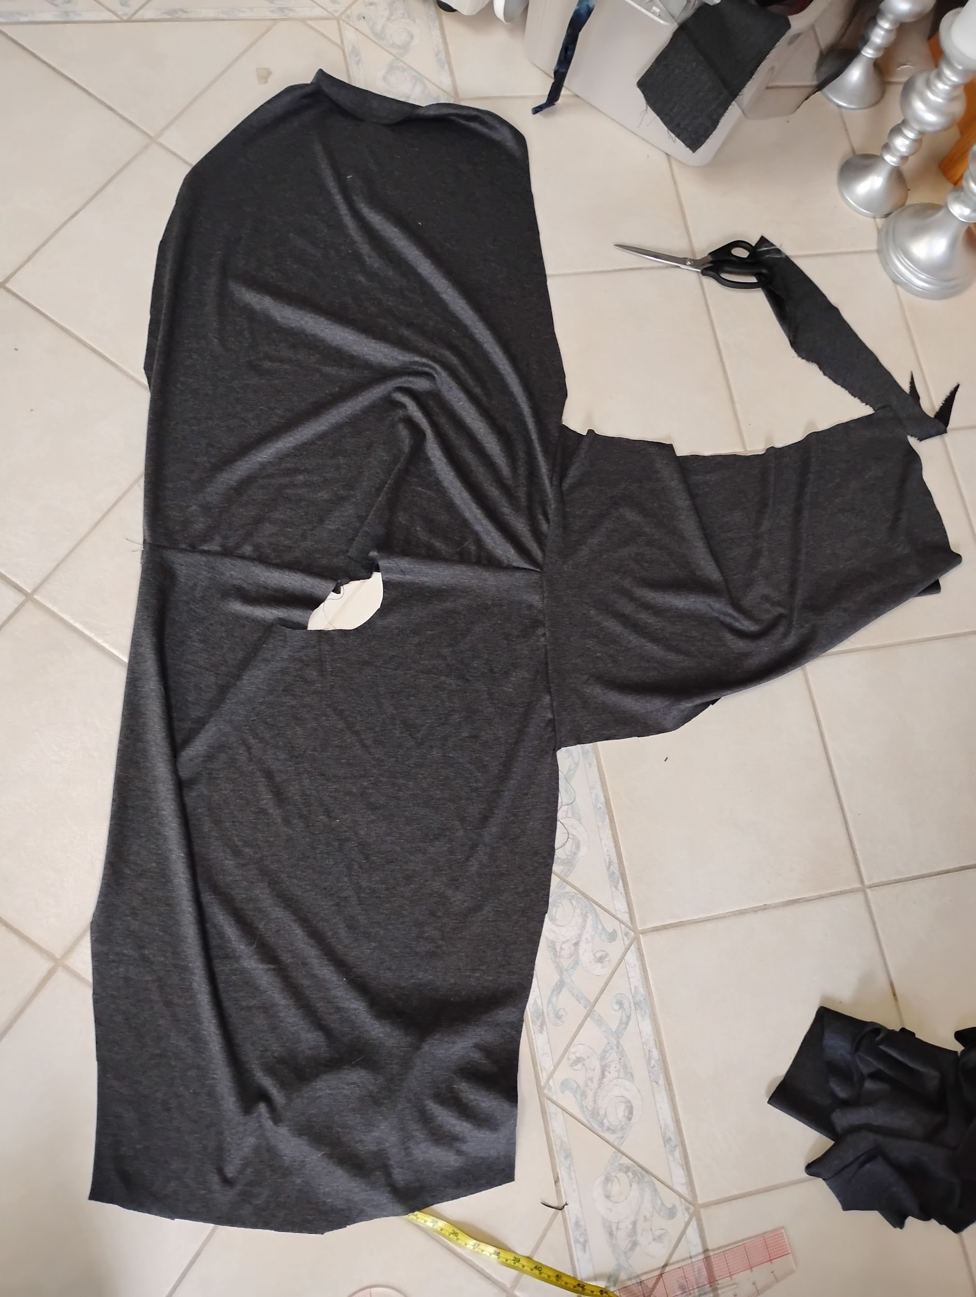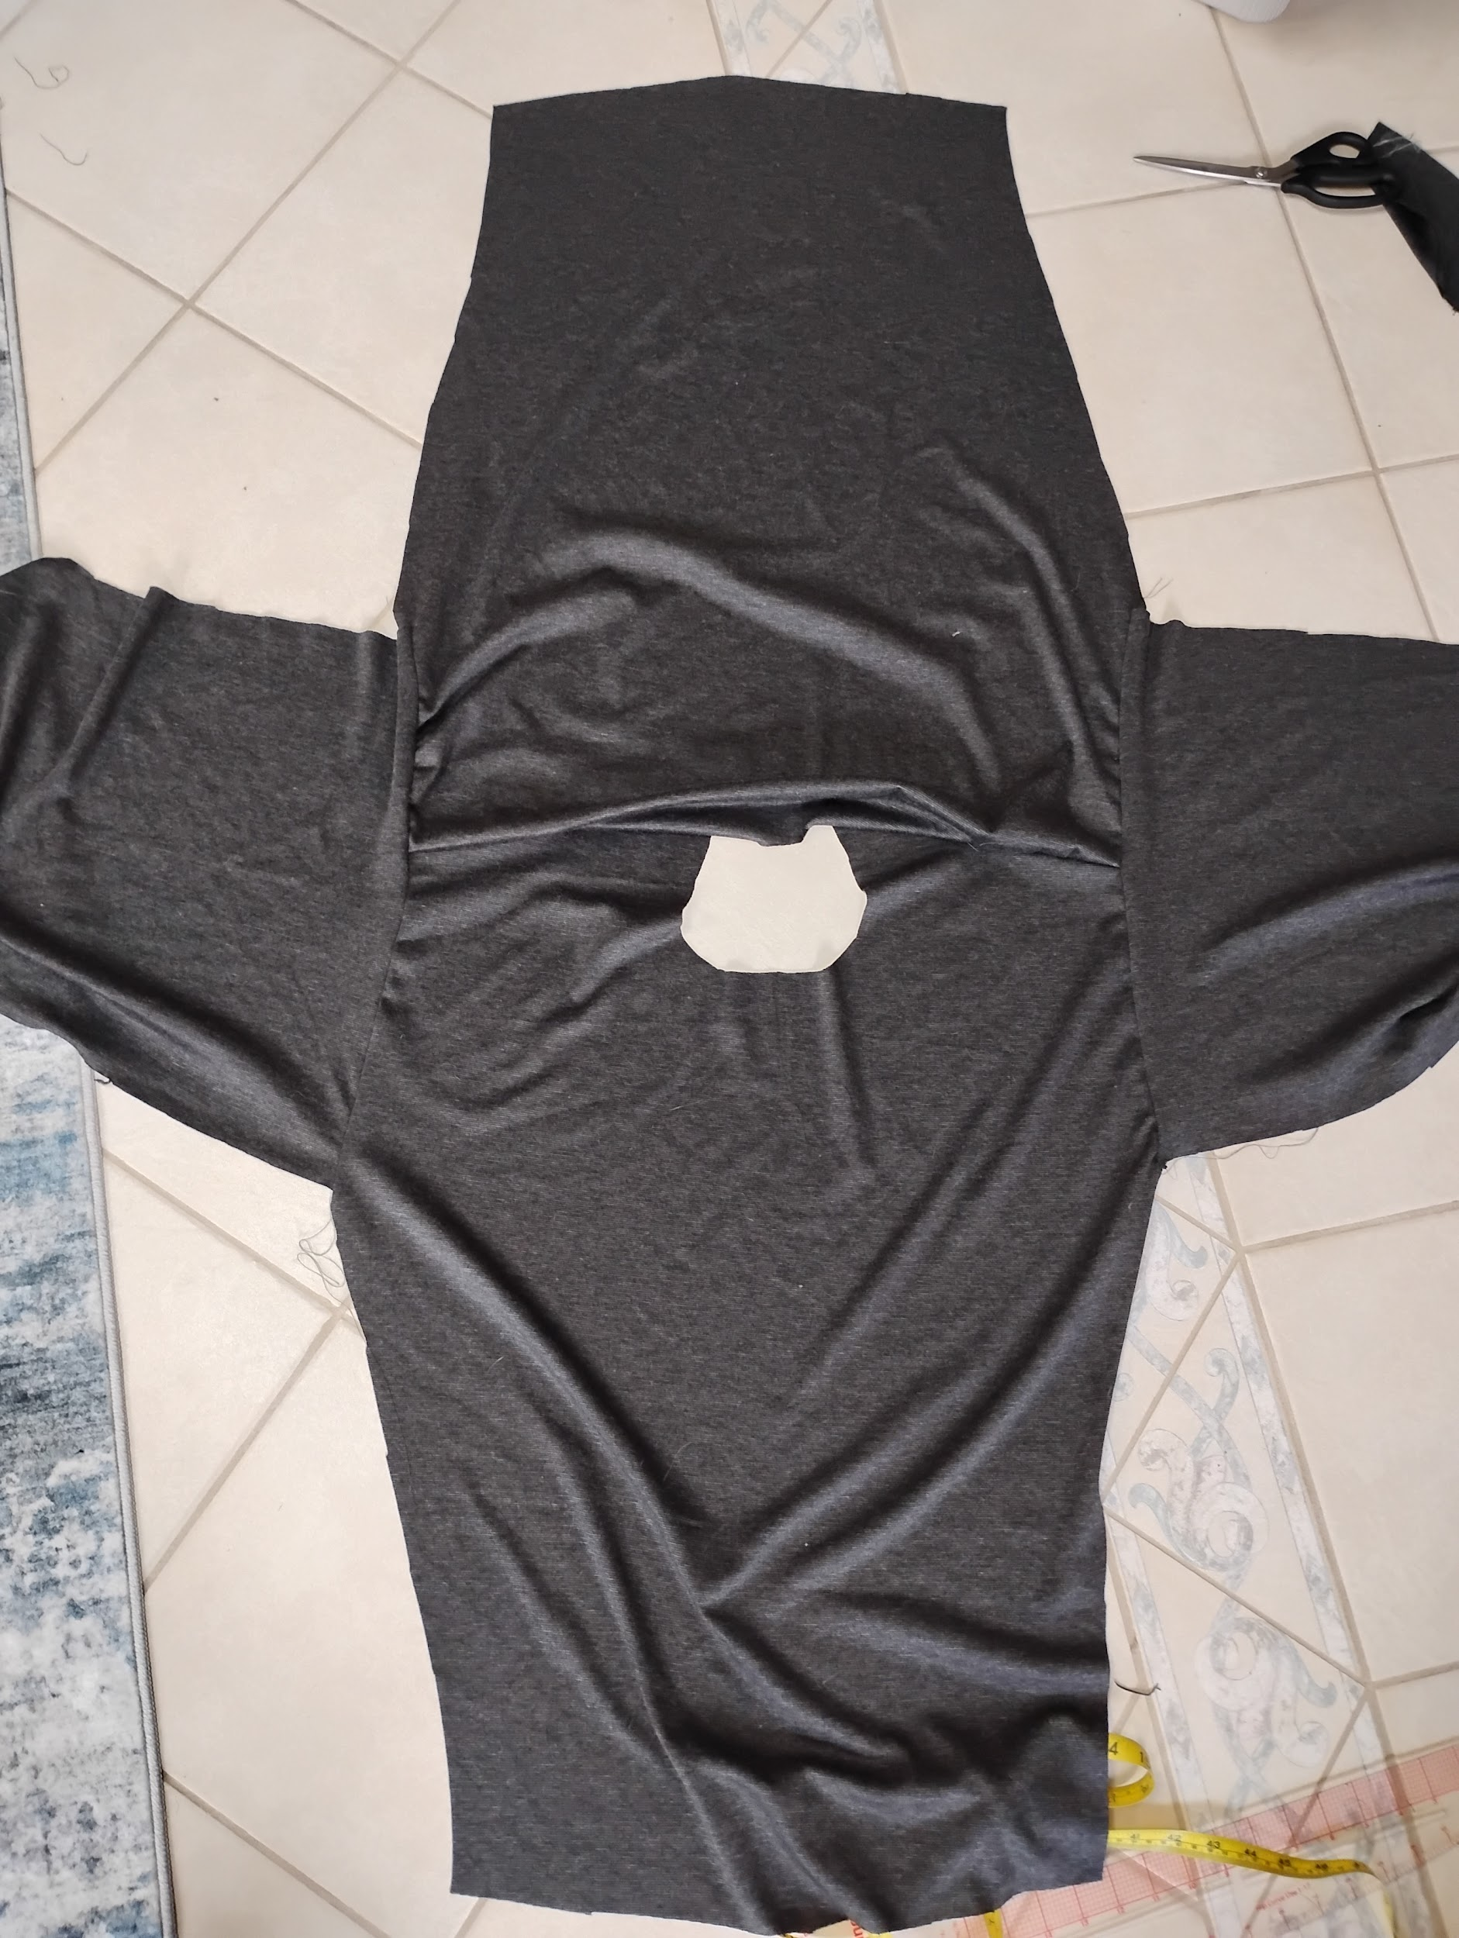

Step 7:

Sew down the sides! I started at the end of the sleeves and down the sides. I know there is a correct direction and not sure if it's the one I did. I had to cut and adjust to make it look equal. Part of the process when I just kinda whip something up.

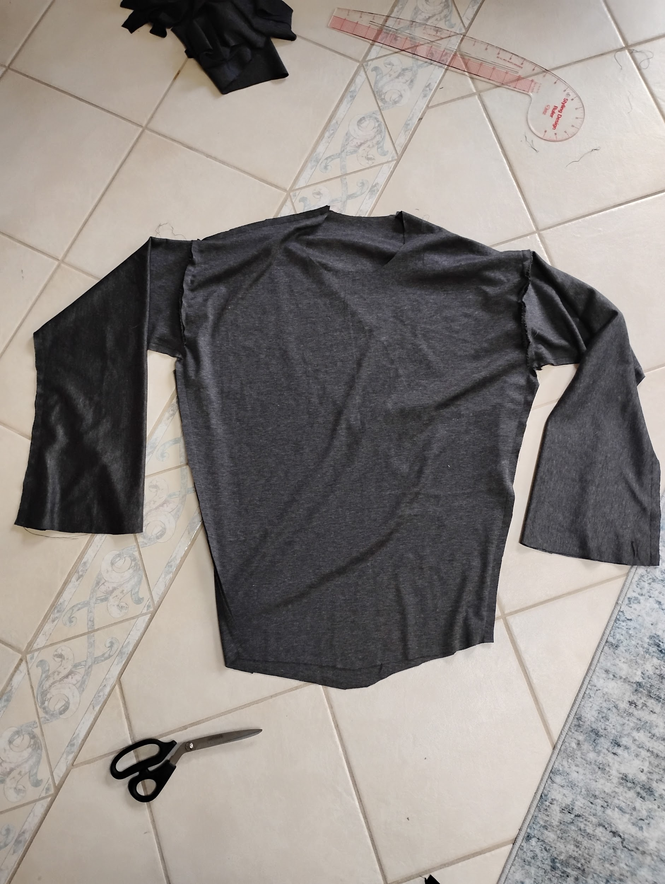

Step 8:

Add the wristbands by measuring this amount and reducing it by 50% at most. The smaller the wristbands the more it will need to stretch to fit the arms wristhole. Sew them in and you'll have a nice matching billowy top.

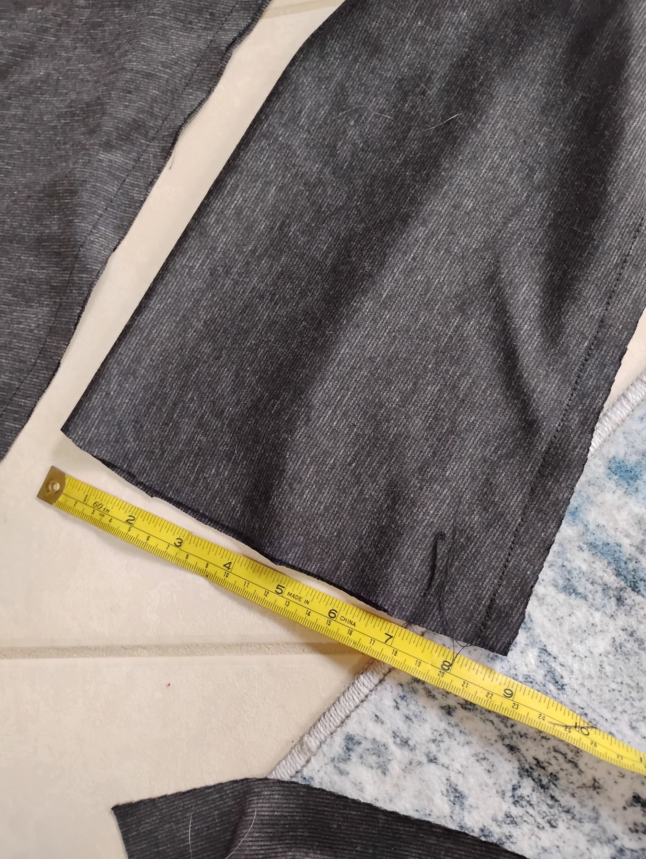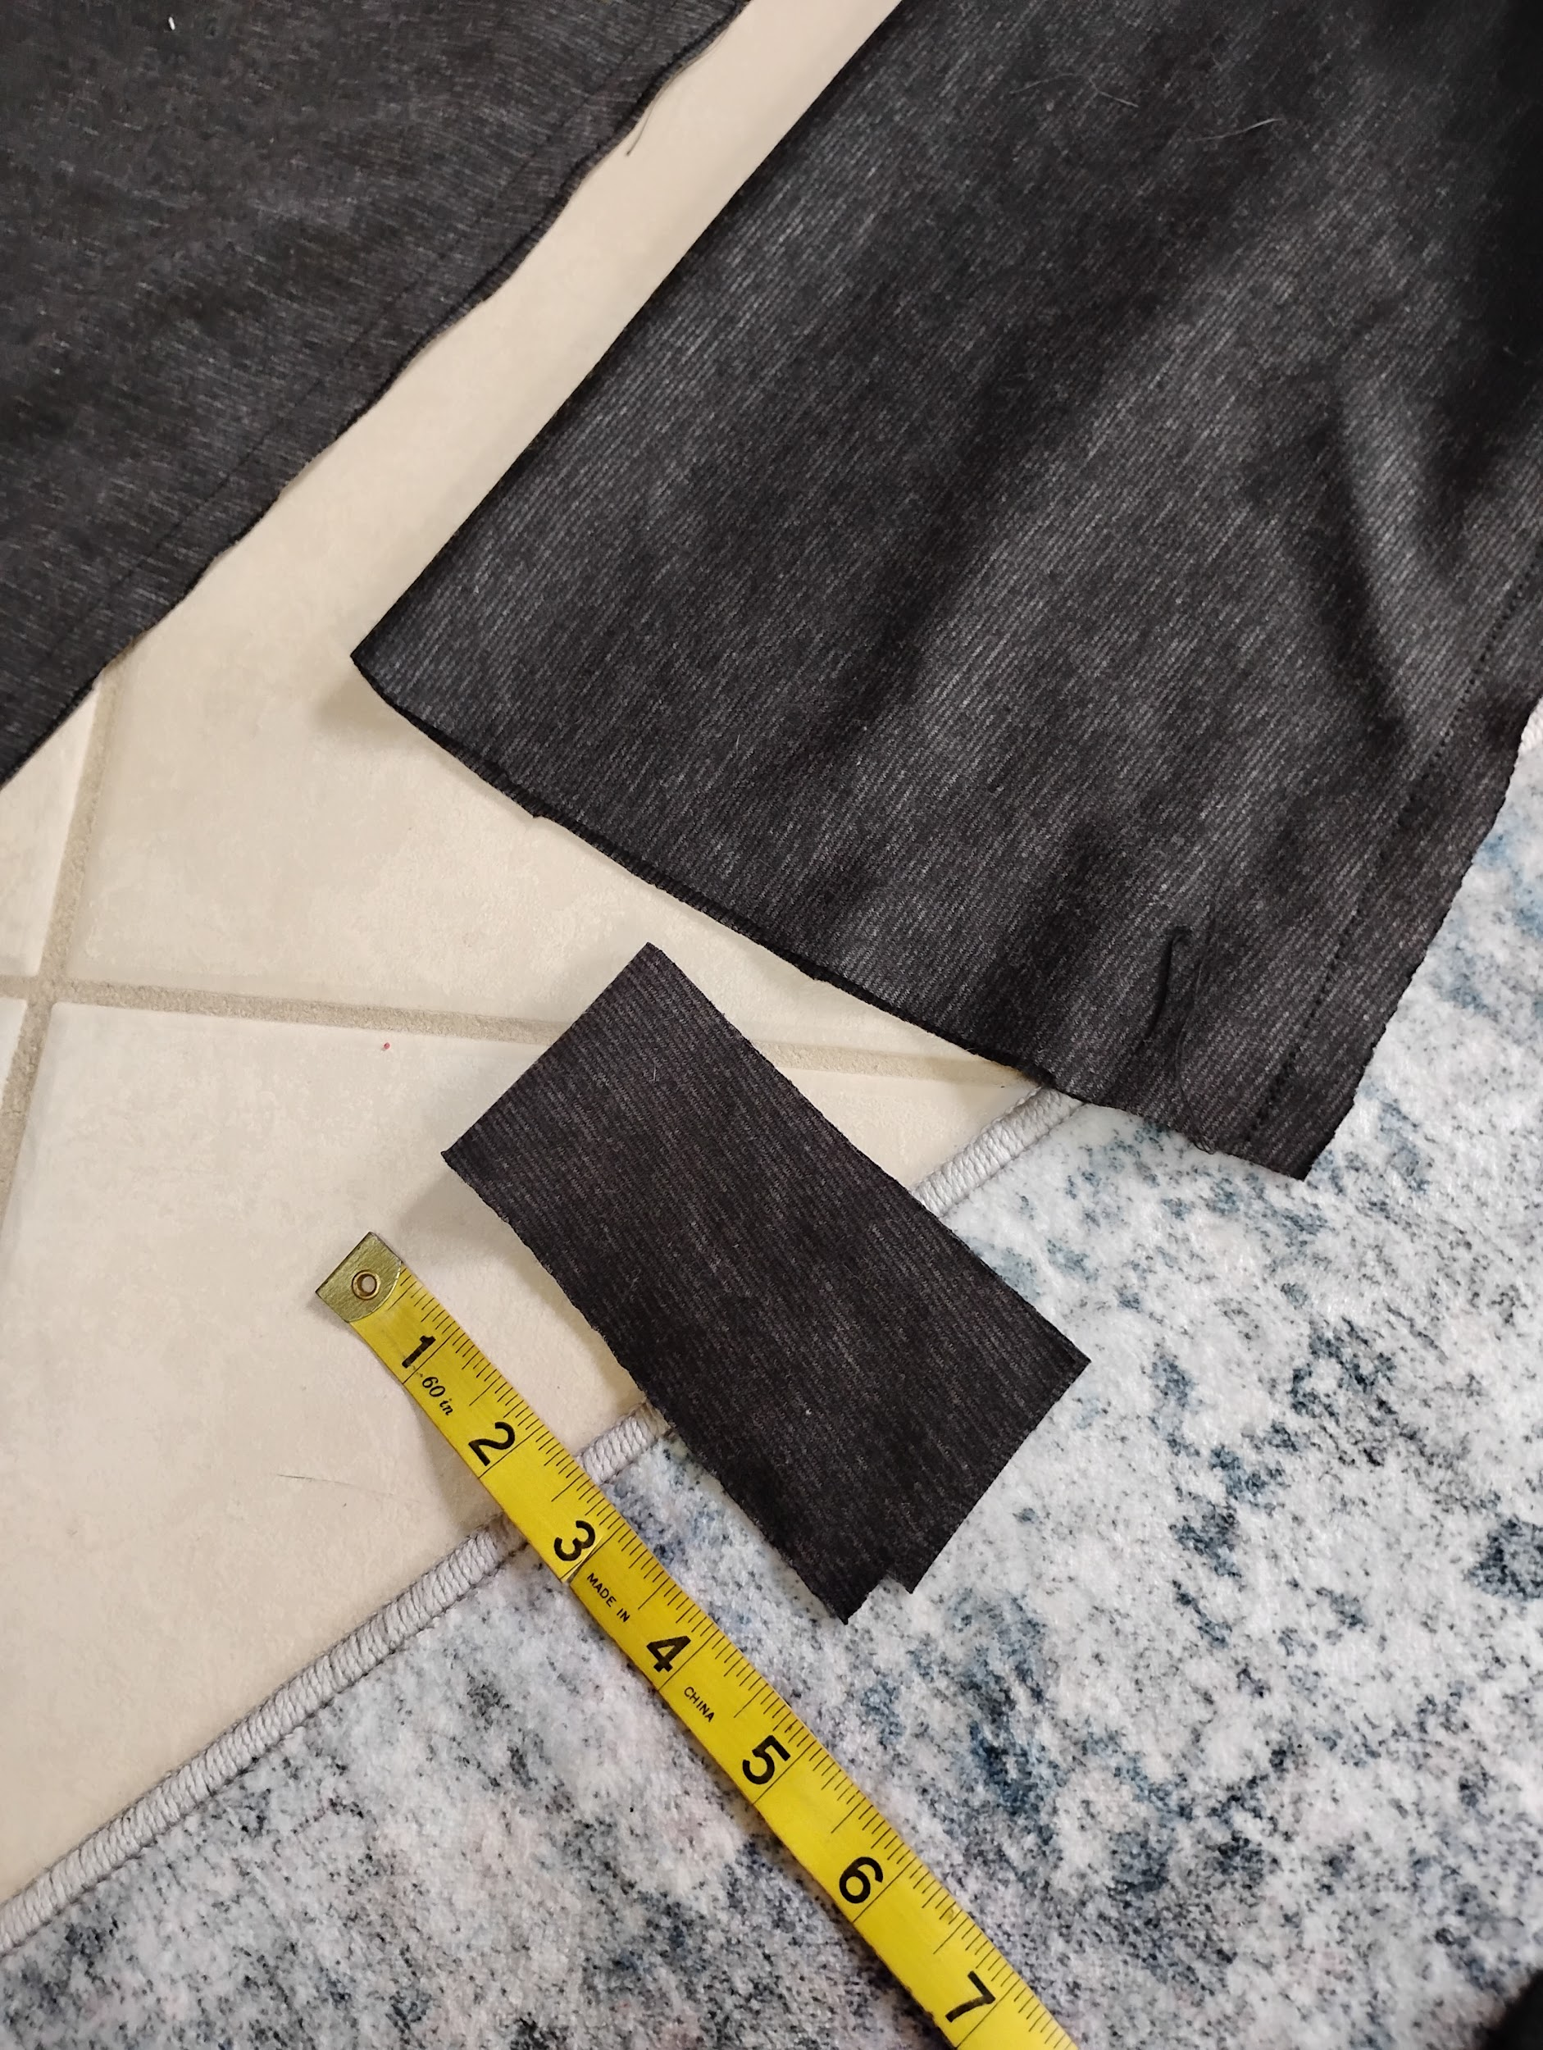

Step 9 (optional):

For the neckline… you can do a variety of things from the place we left it. You can measure the neckline and subtract about 15% to find the length of fabric you need for a nice fitting neckband. A rectangle of the neckband length by about 2 inches makes a nice start for a neckband.

You can also draft a hood, put a on nice knit finish embroidery stitch or just leave it alone. Mine doesn't have anything on the neck because I haven't decided what to add yet. I'll update this document as I go.

